
BDS Third Professional General Surgery
LAHORE MEDICAL & DENTAL COLLEGE LAHORE
Annual Examination 2018
Objectively Structured Performance Evaluation (OSPE)
Static Station No 9
Marks: 03 Time Allowed: 03 min
For Organizer:
Requirements:

1.Response sheet 2.pen/ball point 3. Table 4. Chair / stool

Topic Specification: Radiograph

.......................................................................................................................................

Static Station No 9
Marks:03 Time Allowed: 03 min
For Candidate:

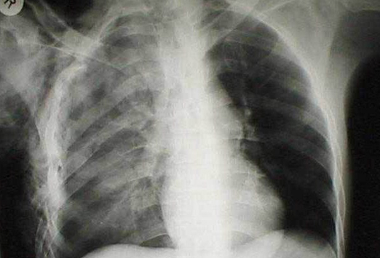
Tasks:

A 24 years old male got chest trauma in an accident. Here is the radiograph Chest of this patient

- What is the diagnosis 1
- What clinical symptoms & signs are expected 1
- What is treatment 1

......................................................................................................................................

Key: Static Station No 9

- Pneumothorax 1
- Chest pain, dyspnea, tachypnea 1
- Insertion of chest tube in the pleural cavity 1

BDS Third Professional General Surgery
LAHORE MEDICAL & DENTAL COLLEGE LAHORE
Annual Examination 2018
Objectively Structured Performance Evaluation (OSPE)
Static Station No 9
Marks: 03 Time Allowed: 03 min
For Organizer:
Requirements:

1.Response sheet 2.pen/ball point 3. Table 4. Chair / stool

Topic Specification: Radiograph

.......................................................................................................................................

Static Station No 9
Marks:03 Time Allowed: 03 min
For Candidate:

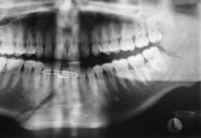
Tasks:

A 34 years old male got facia trauma in an accident. Here is the OPG of this patient

- What is the diagnosis 1
- What are different types of this condition 1
- What are treatment options 1

.......................................................................................................................................

Key: Static Station No 9

- Fracture mandible 1
- condylar, coronoid process, ramus, angle of mandible, body (molar and premolar areas), para-symphysis and symphysis. 1
- Open reduction and fixation by wiring, plating. closed reduction and fixation 1

BDS Third Professional General Surgery
LAHORE MEDICAL & DENTAL COLLEGE LAHORE
Annual Examination 2018
Objectively Structured Performance Evaluation (OSPE)
Static Station No 9
Marks: 03 Time Allowed: 03 min
For Organizer:
Requirements:

1.Response sheet 2.pen/ball point 3. Table 4. Chair / stool

Topic Specification: Radiograph

.......................................................................................................................................

Static Station No 9
Marks:03 Time Allowed: 03 min
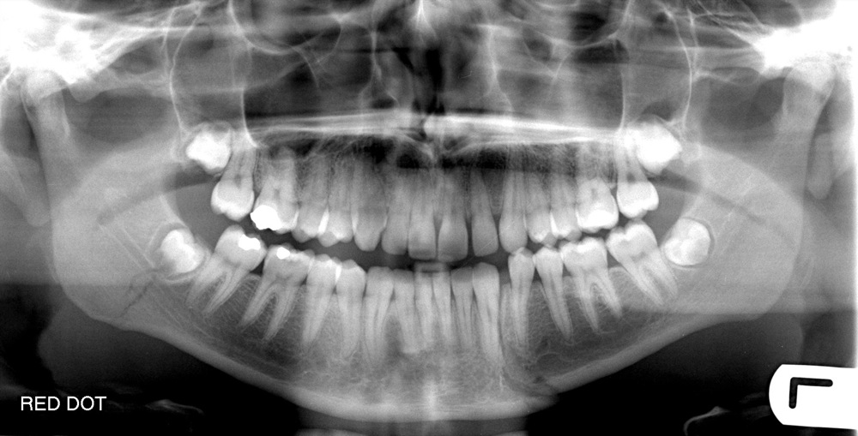
For Candidate:

Tasks:

A 34 years old male got facia trauma in an accident. Here is the OPG of this patient

- How will you classify maxillary fracture 1
- What are treatment options 2

......................................................................................................................................

Key: Static Station No 9

- Le Foert I,II,III 1
- inter-maxillary fixation , wiring and plating 2

