
BDS Third Professional General Surgery
LAHORE MEDICAL & DENTAL COLLEGE LAHORE
Annual Examination 2018
Objectively Structured Performance Evaluation (OSPE )
Static Station No 8
Marks: 03 Time Allowed: 03 min
For Organizer:
Requirements:

1.Response sheet 2.pen/ball point 3. Table 4. Chair / stool

Topic Specification:

.......................................................................................................................................

Static Station No 8
Mark:03 Time Allowed: 03 min
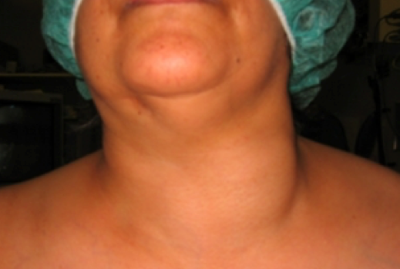
For Candidate:

Tasks:

A 40 year female patient presented to OPD with nodular swelling in front of her neck for 4 years

1. How you will confirm Euthyroid status in this patient
2. Enlist two indications for surgery Thyroidectomy
3. Name three postoperative complication of
.......................................................................................................................................

Key: Static Station No 8

1. History and clinical Examination, thyroid function test, thyroid scan
2. Compression symptoms (difficulty in swallowing and dyspnea) and Cosmetic
3. Hemorrhage, Hypocalcemia, Recurrent laryngeal nerve Injury

BDS Third Professional General Surgery
LAHORE MEDICAL & DENTAL COLLEGE LAHORE
Annual Examination 2018
Objectively Structured Performance Evaluation (OSPE )
Static Station No 8
Marks: 03 Time Allowed: 03 min
For Organizer:
Requirements:

1.Response sheet 2.pen/ball point 3. Table 4. Chair / stool

Topic Specification:

.......................................................................................................................................

Static Station No 8
Mark:03 Time Allowed: 03 min
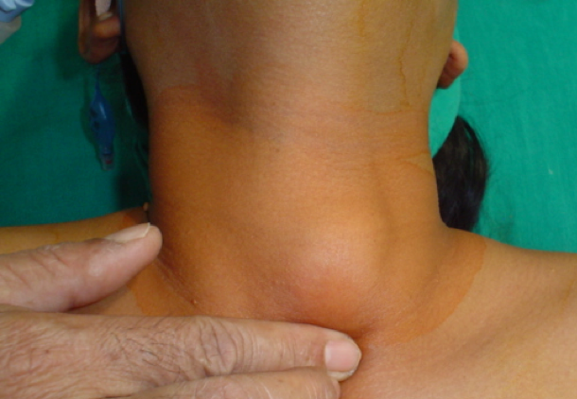
For Candidate:

Tasks:

29 year old female patient seen in OPD for a small swelling in front of neck that moves with swallowing. Patient is clinically Euthyroid

1. Enlist investigation for this case
2. What is the incidence of malignancy in such swelling
3. Name different types of Thyroid Cancers
.......................................................................................................................................

Key: Static Station No 8

1. Ultrasound Neck, FNAC, Thyroid Scan Thyroid profile
2. 15% risk of Papillary Carcinoma Thyroid
3. Papillary Carcinoma, Follicular Carcinoma, Medullary Carcinoma, Anapaestic Carcinoma

BDS Third Professional General Surgery
LAHORE MEDICAL & DENTAL COLLEGE LAHORE
Annual Examination 2018
Objectively Structured Performance Evaluation (OSPE )
Static Station No 8
Marks: 03 Time Allowed: 03 min
For Organizer:
Requirements:

1.Response sheet 2.pen/ball point 3. Table 4. Chair / stool

Topic Specification: Post-operative care

.......................................................................................................................................

Static Station No 8
Mark:03 Time Allowed: 03 min
For Candidate:
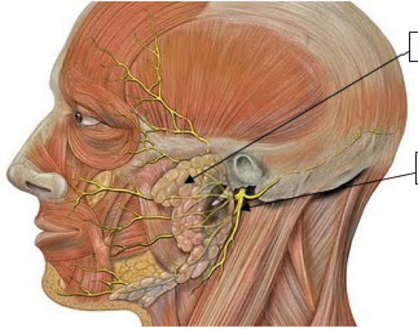
Tasks:

Carefully see the picture and answer the following questions

1. Identify the two structures marked with arrows
2. What will happen if buccal and mandibular branches are damaged during dissection
......................................................................................................................................

Key: Static Station No 8

1. Parotid Gland, Facial nerve
2.
a. Buccal n. paresis of elevator of upper lip
b. Marginal mandibular n. loss of smile expression as it supply circumoral muscle, paralysis of lower lip muscle

BDS Third Professional General Surgery
LAHORE MEDICAL & DENTAL COLLEGE LAHORE
Annual Examination 2018
Objectively Structured Performance Evaluation (OSPE )
Static Station No 8
Marks: 03 Time Allowed: 03 min
For Organizer:
Requirements:

1.Response sheet 2.pen/ball point 3. Table 4. Chair / stool

Topic Specification: Post-operative care

.......................................................................................................................................

Static Station No 8
Mark:03 Time Allowed: 03 min
For Candidate:

Tasks:
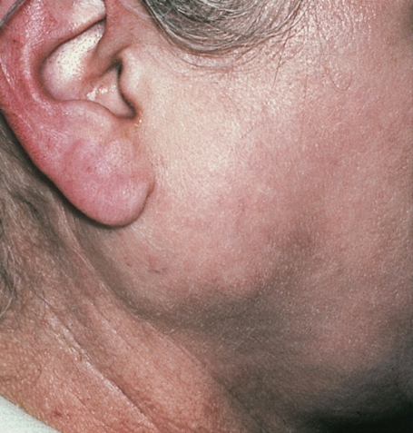

45 year male patient was seen in OPD for swelling on the right side of his face for 6 months. He is worried as now it is painful for few weeks

1. What is your diagnosis
2. Name investigation to confirm your diagnosis
3. Name operative procedure for this case
.......................................................................................................................................

Key: Static Station No 3

1. Pleomorphic Adenoma of Parotid Gland
2. Ultrasound , FNAC
3. Superficial Parotidectomy
BDS Third Professional General Surgery
LAHORE MEDICAL & DENTAL COLLEGE LAHORE
Annual Examination 2018
Objectively Structured Performance Evaluation (OSPE )
Static Station No 8
Marks: 03 Time Allowed: 03 min
For Organizer:
Requirements:

1.Response sheet 2.pen/ball point 3. Table 4. Chair / stool

Topic Specification:
.......................................................................................................................................

Static Station No 8
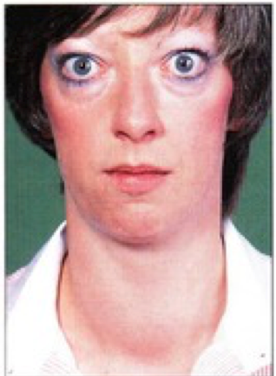
Mark:03 Time Allowed: 03 min
For Candidate:

Tasks:
Carefully see this picture and answer following questions
1. What is the clinical problem in this patient
2. Enlist three question you would like to ask this patient in history which can help in management
3. Advice three appropriate investigation for this patient
......................................................................................................................................

Key: Static Station No 2

1. Graves Disease(patient has enlarged thyroid with exophthalmos)
2. a. Do you have palpitation
b. Do you have tremors in her hand
c. Have you lost your weight
d. Do you have medical treatment before
3. Thyroid profile, thyroid antibodies, ultrasound neck
BDS Third Professional General Surgery
LAHORE MEDICAL & DENTAL COLLEGE LAHORE
Annual Examination 2018
Objectively Structured Performance Evaluation (OSPE )
Static Station No 8
Marks: 03 Time Allowed: 03 min
For Organizer:
Requirements:

1.Response sheet 2.pen/ball point 3. Table 4. Chair / stool

Topic Specification:
.......................................................................................................................................

Static Station No 8
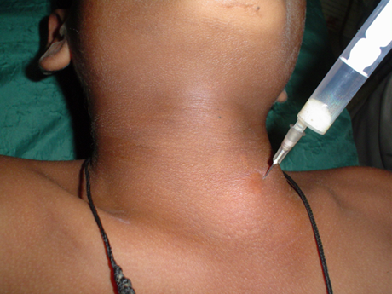
Mark:03 Time Allowed: 03 min
For Candidate:

Tasks: A young female patient was seen in surgical clinics for solitary nodule in front of neck. She was advised workup

1. Identify the procedure in this picture
2. What precaution must be taken care off
3. How much is the specificity of this test for malignancy diagnosis
4. Indicate advantages and disadvantages
.......................................................................................................................................

Key: Static Station No 8

1. Fine Needle Aspiration Cytology
2. a.Normal Coagulation profile b. Ultrasound guided procedure can improve on its reporting c. Avoid injury to vessels
3. Sensitivity 95%, specificity 90%
4. a. Minimal intervention /less invasive with early results
b. Cost effective
c. Sensitivity is in positive results only
d. False negative results e. It cannot give a tissue diagnosis f. It is technician dependant procedure
BDS Third Professional General Surgery
LAHORE MEDICAL & DENTAL COLLEGE LAHORE
Annual Examination 2018
Objectively Structured Performance Evaluation (OSPE )
Static Station No 8
Marks: 03 Time Allowed: 03 min
For Organizer:
Requirements:

1.Response sheet 2.pen/ball point 3. Table 4. Chair / stool

Topic Specification: Post-operative care

.......................................................................................................................................

Static Station No 8
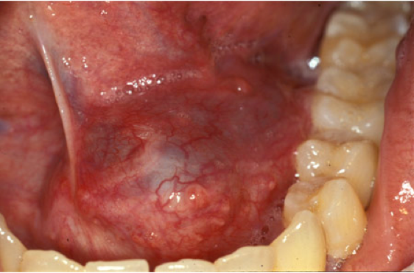
Mark:03 Time Allowed: 03 min
For Candidate:

Tasks:
Carefully see the picture of this young lady with a soft swelling in the floor of Mouth

1. Give your diagnosis
2. What is appropriate treatment for this

.......................................................................................................................................

Key: Static Station No 3

1. Ranula floor of mouth
2. Excision and Marsuplization

