
BDS Third Professional General Surgery
LAHORE MEDICAL & DENTAL COLLEGE LAHORE
Annual Examination 2018
Objectively Structured Performance Evaluation (OSPE )
Static Station No 7
Marks: 03 Time Allowed: 03 min
For Organizer:
Requirements:

1.Response sheet 2.pen/ball point 3. Table 4. Chair / stool

Topic Specification: Instruments

.......................................................................................................................................

Static Station No 7
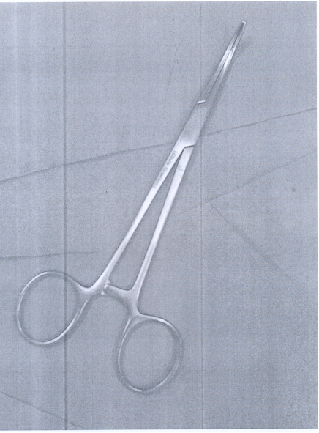
Mark:03 Time Allowed: 03 min
For Candidate:

Tasks:

1. What is this instrument?
2. What are its Uses?
3. How it is sterilized?

.......................................................................................................................................

Key: Static Station No 7

1. Artery forceps
2. a. For hemostasis b. To hold aponeurosis or peritoneal
3. Autoclave

BDS Third Professional General Surgery
LAHORE MEDICAL & DENTAL COLLEGE LAHORE
Annual Examination 2018
Objectively Structured Performance Evaluation (OSPE )
Static Station No 7
Marks: 03 Time Allowed: 03 min
For Organizer:
Requirements:

1.Response sheet 2.pen/ball point 3. Table 4. Chair / stool

Topic Specification: Instruments

.......................................................................................................................................

Static Station No 7
Mark:03 Time Allowed: 03 min
For Candidate:
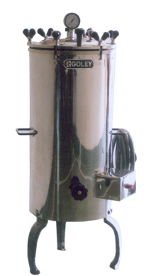
Tasks:

1. Identify the item
2. Write down the principle of its use
3. Name two objects which can be sterilized with this method

.......................................................................................................................................

Key: Static Station No 7

1. Autoclave
2. 121⁰C at pressure 15psi for 15min
3. a. Surgical instruments
b. Hospital beddings and drapes

BDS Third Professional General Surgery
LAHORE MEDICAL & DENTAL COLLEGE LAHORE
Annual Examination 2018
Objectively Structured Performance Evaluation (OSPE )
Static Station No 7
Marks: 03 Time Allowed: 03 min
For Organizer:
Requirements:

1.Response sheet 2.pen/ball point 3. Table 4. Chair / stool

Topic Specification: Instruments

.......................................................................................................................................

Static Station No 7
Mark:03 Time Allowed: 03 min
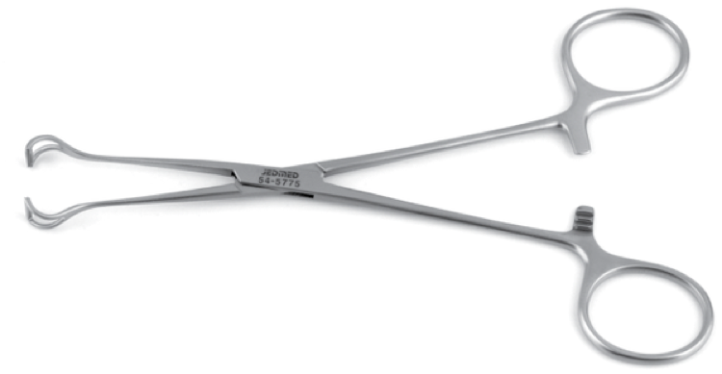
For Candidate:

Tasks:

1. Identify the instrument
2. Write down method to sterilize this instrument
3. What are the uses of this instrument? Give two example?

.......................................................................................................................................

Key: Static Station No 7

1. Babcock Forceps
2. Autoclave
3. Used to grasp softer tissue, for example to hold appendix and bowel

BDS Third Professional General Surgery
LAHORE MEDICAL & DENTAL COLLEGE LAHORE
Annual Examination 2018
Objectively Structured Performance Evaluation (OSPE )
Static Station No 7
Marks: 03 Time Allowed: 03 min
For Organizer:
Requirements:

1.Response sheet 2.pen/ball point 3. Table 4. Chair / stool

Topic Specification: Instruments

.......................................................................................................................................

Static Station No 7
Mark:03 Time Allowed: 03 min
For Candidate:
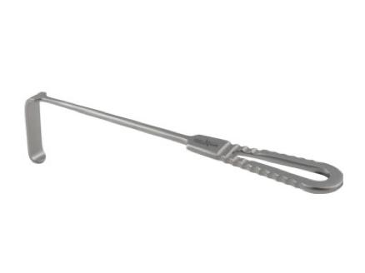
Tasks:

1. Identify the instrument
2. Write down method to sterilize this instrument
3. What are the uses of this instrument? Give two example?

.......................................................................................................................................

Key: Static Station No 7

1. Langenbeck Retractor
2. Autoclave
3. Holding open wounds and exposing deeper tissues

BDS Third Professional General Surgery
LAHORE MEDICAL & DENTAL COLLEGE LAHORE
Annual Examination 2018
Objectively Structured Performance Evaluation (OSPE )
Static Station No 7
Marks: 03 Time Allowed: 03 min
For Organizer:
Requirements:

1.Response sheet 2.pen/ball point 3. Table 4. Chair / stool

Topic Specification: Instruments

.......................................................................................................................................

Static Station No 7
Mark:03 Time Allowed: 03 min
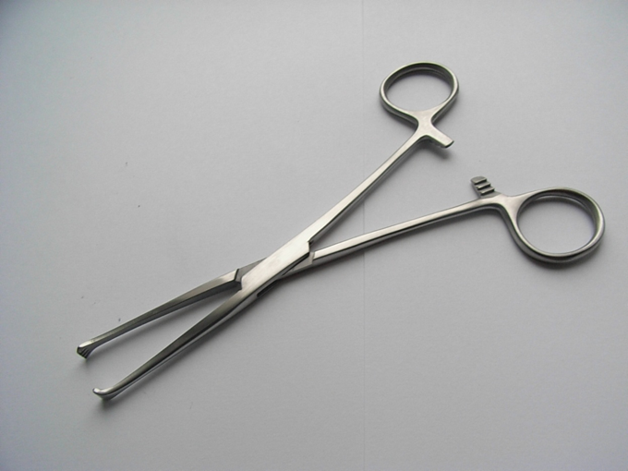
For Candidate:

Tasks:

1. Identify the instrument
2. Write down method to sterilize this instrument
3. What are the uses of this instrument? Give two example?

.......................................................................................................................................

Key: Static Station No 7

1. Allis Forceps
2. Autoclave. Ethylene oxide,
3. Holding soft tissue and used to provide gentle traction . For example, 5g

BDS Third Professional General Surgery
LAHORE MEDICAL & DENTAL COLLEGE LAHORE
Annual Examination 2018
Objectively Structured Performance Evaluation (OSPE )
Static Station No 7
Marks: 03 Time Allowed: 03 min
For Organizer:
Requirements:

1.Response sheet 2.pen/ball point 3. Table 4. Chair / stool

Topic Specification: Instruments

.......................................................................................................................................

Static Station No 7
Mark:03 Time Allowed: 03 min
For Candidate:
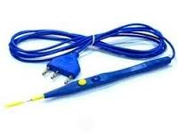
Tasks:

- identify this object
- what are its uses
- what are its contraindications

.......................................................................................................................................

Key: Static Station No 7

- cautery lead
- To coagulate small bleeding points, to cut the tissue
- it is contraindicated in circumcision and patients having pacemakers.

