
BDS Third Professional General Surgery
LAHORE MEDICAL & DENTAL COLLEGE LAHORE
Annual Examination 2018
Objectively Structured Performance Evaluation (OSPE )
Static Station No 4
Marks: 03 Time Allowed: 03 min
For Organizer:
Requirements:

1.Response sheet 2.pen/ball point 3. Table 4. Chair / stool

Topic Specification: Drains

.....................................................................................................................................

Static Station No 4
Mark:03.
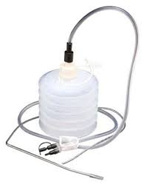

For Candidate:

Tasks:

- Identify this object 1
- What are its uses 2

....................................................................................................................................

Key: Static Station No 4

- Suction drain 1
- To drain close cavities after surgery ,To prevent the accumulation of fluid (blood, pus and infected fluids).To prevent accumulation of air (dead space).To characterize fluid (for example, early identification of anastomotic leakage 2

BDS Third Professional General Surgery
LAHORE MEDICAL & DENTAL COLLEGE LAHORE
Annual Examination 2018
Objectively Structured Performance Evaluation (OSPE )
Static Station No 4
Marks: 03 Time Allowed: 03 min
For Organizer:
Requirements:

1.Response sheet 2.pen/ball point 3. Table 4. Chair / stool

Topic Specification: Drains

.......................................................................................................................................

Static Station No 4
Mark:03 Time Allowed: 03 min
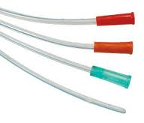
For Candidate:

Tasks:

- Identify this object 1
- What are its uses 2

......................................................................................................................................

Key: Static Station No 4

- Nelton drain 1
- To drain abdominal cavity after surgery ,To prevent the accumulation of fluid (blood, pus and infected fluids).To characterise fluid (for example, early identification of anastomotic leakage 2

BDS Third Professional General Surgery
LAHORE MEDICAL & DENTAL COLLEGE LAHORE
Annual Examination 2018
Objectively Structured Performance Evaluation (OSPE )
Static Station No 4
Marks: 03 Time Allowed: 03 min
For Organizer:
Requirements:

1.Response sheet 2.pen/ball point 3. Table 4. Chair / stool

Topic Specification: Drains

.......................................................................................................................................

Static Station No 4
Mark:03 Time Allowed: 03 min
For Candidate:
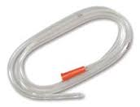
Tasks:

- Identify this object 1
- What are its uses 2

......................................................................................................................................

Key: Static Station No 10

- Nasogastric tube 1
- To decompress the stomach, for post-operative ileus, for gastric lavage 2

BDS Third Professional General Surgery
LAHORE MEDICAL & DENTAL COLLEGE LAHORE
Annual Examination 2018
Objectively Structured Performance Evaluation (OSPE )
Static Station No 4
Marks: 03 Time Allowed: 03 min
For Organizer:
Requirements:

1.Response sheet 2.pen/ball point 3. Table 4. Chair / stool

Topic Specification: Drains

.......................................................................................................................................

Static Station No 4
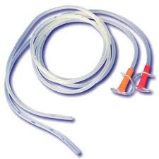
Mark:03 Time Allowed: 03 min
For Candidate:

Tasks:

- Identify this object 1
- What are its complication 2

......................................................................................................................................

Key: Static Station No 4

- Feeding Tube 1
- Infection, bleeding, aspiration of lungs, otitis media , trauma to esophagus 2

BDS Third Professional General Surgery
LAHORE MEDICAL & DENTAL COLLEGE LAHORE
Annual Examination 2018
Objectively Structured Performance Evaluation (OSPE )
Static Station No 4
Marks: 03 Time Allowed: 03 min
For Organizer:
Requirements:

1.Response sheet 2.pen/ball point 3. Table 4. Chair / stool

Topic Specification: Tubes

.......................................................................................................................................

Static Station No 4
Mark:03 Time Allowed: 03 min
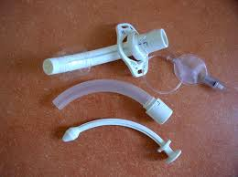
For Candidate:

Tasks:

- Identify this object 1
- What are its complication 2

.......................................................................................................................................

Key: Static Station No 4

- Tracheotomy Tube 1
- Infection, bleeding, aspiration of lungs, tracheoesophageal fistula 2

