
BDS Third Professional General Surgery
LAHORE MEDICAL & DENTAL COLLEGE LAHORE
Annual Examination 2018
Objectively Structured Performance Evaluation (OSPE )
Static Station No 2
Marks: 03 Time Allowed: 03 min
For Organizer:
Requirements:

1.Response sheet 2.pen/ball point 3. Table 4. Chair / stool

Topic Specification: Tubes

.......................................................................................................................................

Static Station No 2
Marks:03 Time Allowed: 03 min
For Candidate:
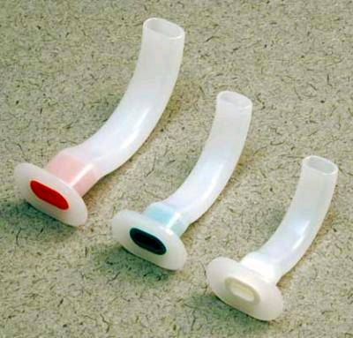
Tasks:

Carefully observe the picture and answer the following questions

- identify these objects 1
- What are its uses 1
- How it works 1

......................................................................................................................................

Key: Static Station No 2

- Oropharyngeal Airways 1
- To maintain airway in unconscious patient and to avoid clinching endotracheal tube during light general anesthesia 1
- It prevents tongue fall and opening is for air entry 1

BDS Third Professional General Surgery
LAHORE MEDICAL & DENTAL COLLEGE LAHORE
Annual Examination 2018
Objectively Structured Performance Evaluation (OSPE )
Static Station No 2
Marks: 03 Time Allowed: 03 min
For Organizer:
Requirements:

1.Response sheet 2.pen/ball point 3. Table 4. Chair / stool

Topic Specification: Tubes

.......................................................................................................................................

Static Station No 2
Marks:03 Time Allowed: 03 min
For Candidate:

Tasks:

Carefully observe the picture and answer the following questions
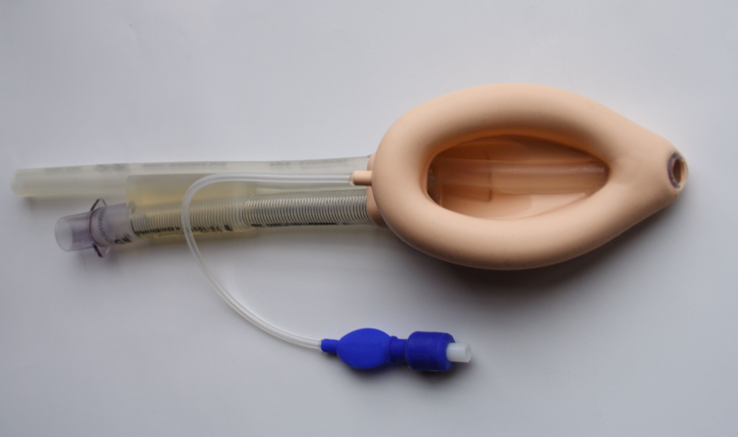
- Identify this object 1
- What are its uses 1
- What are its advantage 1

.......................................................................................................................................

Key: Static Station No 2

- Laryngeal mask airway (LMA) 1
- To maintain airway during general anesthesia and in emergency room in unconscious patients 1
- It is easy to insert, less irritant and traumatic to airway 1

BDS Third Professional General Surgery
LAHORE MEDICAL & DENTAL COLLEGE LAHORE
Annual Examination 2018
Objectively Structured Performance Evaluation (OSPE )
Static Station No 2
Marks: 03 Time Allowed: 03 min
For Organizer:
Requirements:

1.Response sheet 2.pen/ball point 3. Table 4. Chair / stool

Topic Specification: Tubes

......................................................................................................................................

Static Station No 2
Marks:03 Time Allowed: 03 min
For Candidate:

Tasks:

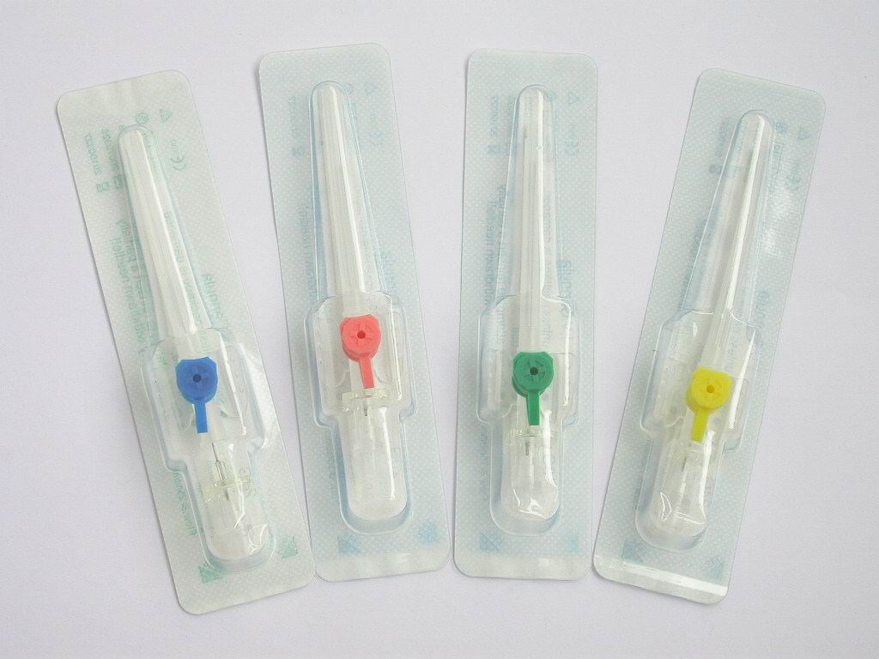
Carefully observe the picture and answer the following questions

- Identify these objects 1
- What are its uses 1
- What are its complications 1

.......................................................................................................................................

Key: Static Station No 2

- Intravenous Cannulas 1
- To maintain intravenous line . To inject injection or infuse fluids. 1
- infections, air embolism, thrombophlebitis, extravasation of fluids 1

BDS Third Professional General Surgery
LAHORE MEDICAL & DENTAL COLLEGE LAHORE
Annual Examination 2018
Objectively Structured Performance Evaluation (OSPE )
Static Station No 2
Marks: 03 Time Allowed: 03 min
For Organizer:
Requirements:

1.Response sheet 2.pen/ball point 3. Table 4. Chair / stool

Topic Specification: Tubes

.......................................................................................................................................

Static Station No2
Marks:03 Time Allowed: 03 min
For Candidate:

Tasks:
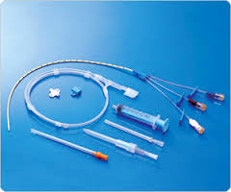
Carefully observe the picture and answer the following questions

- Identify it 1
- What are the routs can be used 1
- What are its complications 1

.......................................................................................................................................

Key: Static Station No 2

- Central venous line set 1
- Internal jugular vein and subclavian vein 1
- Infection, bleeding, air embolism , arrhythmia ,pneumothorax 1

BDS Third Professional General Surgery

LAHORE MEDICAL & DENTAL COLLEGE LAHORE
Annual Examination 2018
Objectively Structured Performance Evaluation (OSPE )
Static Station No 2
Marks: 03 Time Allowed: 03 min
For Organizer:
Requirements:

1.Response sheet 2.pen/ball point 3. Table 4. Chair / stool

Topic Specification: Tubes

................................................................................................................................................

Static Station No 2
Mark:03 Time Allowed: 03 min
For Candidate:

Tasks:

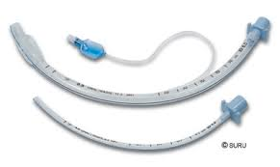
Carefully observe the picture and answer the following questions

- Identify it 1
- What is the difference between two tubes 1
- What are its complications 1

.......................................................................................................................................

Key: Static Station No 2

- Endotracheal Tubes
- one tube has cuff and other is without cuff
- Infection, bleeding, trauma to larynx and trachea, injury to vocal cords

