BDS Third Professional General Surgery
LAHORE MEDICAL & DENTAL COLLEGE LAHORE
Annual Examination 2018
Objectively Structured Performance Evaluation (OSPE )
Static Station No 1
Marks: 03 Time Allowed: 03 min
For Organizer:
Requirements:

1.Response sheet 2.pen/ball point 3. Table 4. Chair / stool

Topic Specification: Sutures

.......................................................................................................................................

Static Station No 1
Marks:03 Time Allowed: 03 min
For Candidate:
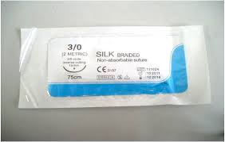
Tasks:

- What is characteristic of this suture 1
- What are the uses 1
- What are the disadvantages 1
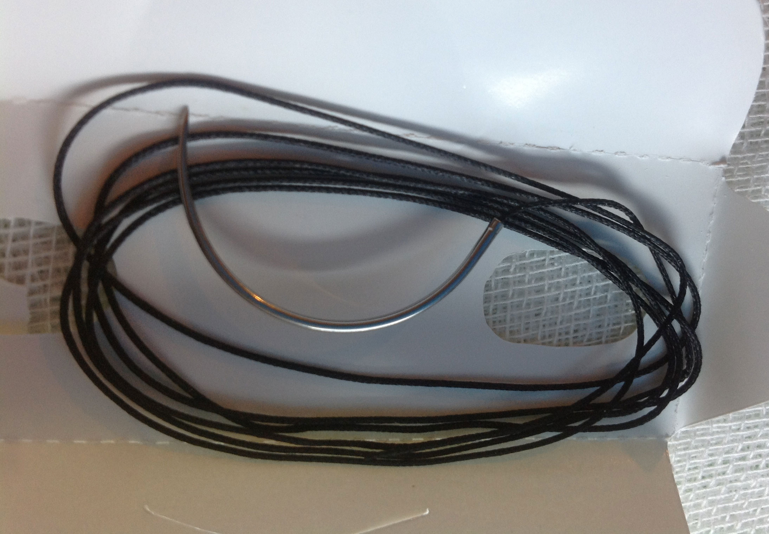

......................................................................................................................................

Key: Static Station No 1

- It is biological non-absorbable suture 1
- it is used to close the skin wounds, to ligate the medium and large size vessels and to anchor the drains. 1
- It can cause infection and more prominent stitch marks on skin. 1


BDS Third Professional General Surgery

LAHORE MEDICAL & DENTAL COLLEGE LAHORE
Annual Examination 2018
Objectively Structured Performance Evaluation (OSPE )
Static Station No 1
Marks: 03 Time Allowed: 03 min
For Organizer:
Requirements:

1.Response sheet 2.pen/ball point 3. Table 4. Chair / stool

Topic Specification: Sutures

.......................................................................................................................................

Static Station No 1
Marks:03 Time Allowed: 03 min
For Candidate:
Tasks:

- How this suture is made 1
- How it is sterilized 1
- What are the Advantages of its use. 1

.......................................................................................................................................

Key: Static Station No 1

- It is made from silk worm 1
- It is sterilized at commercial level by gamma radiations. 1
- It is cheap, easy handling and knotting. 1

BDS Third Professional General Surgery
LAHORE MEDICAL & DENTAL COLLEGE LAHORE
Annual Examination 2018
Objectively Structured Performance Evaluation (OSPE )
Static Station No 1
Marks: 03 Time Allowed: 03 min
For Organizer:
Requirements:

1.Response sheet 2.pen/ball point 3. Table 4. Chair / stool

Topic Specification: Sutures

.......................................................................................................................................

Static Station No 1
Marks:03 Time Allowed: 03 min
For Candidate:
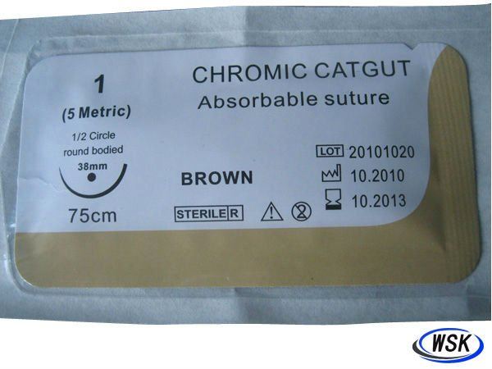
Tasks:

- What is characteristic of this suture 1
- How it is made 1
- What are its two types 1
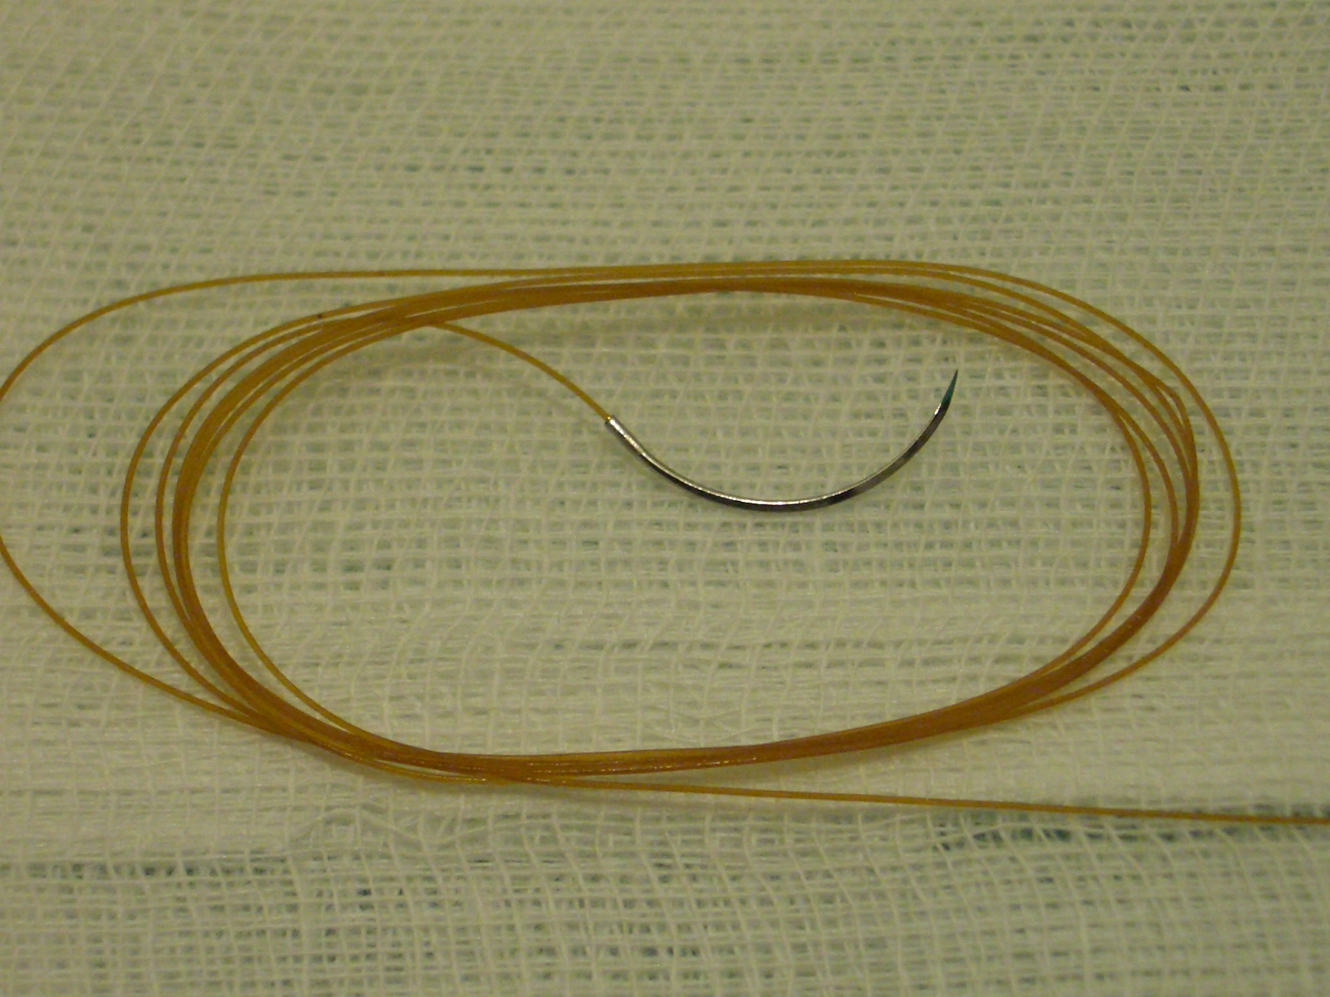

.......................................................................................................................................

Key: Static Station No 1

- It is biological absorbable suture
- It is composed of purified connective tissue (mostly collagen) derived from either the serosal layer of beef (bovine) or the submucosal fibrous .
- Plain cat gut , chromic catgut

BDS Third Professional General Surgery
LAHORE MEDICAL & DENTAL COLLEGE LAHORE
Annual Examination 2018
Objectively Structured Performance Evaluation (OSPE )
Static Station No 1
Marks: 03 Time Allowed: 03 min
For Organizer:
Requirements:

1.Response sheet 2.pen/ball point 3. Table 4. Chair / stool

Topic Specification: Sutures

.......................................................................................................................................

Static Station No 1
Mark:03 Time Allowed: 03 min
For Candidate:

Tasks:
Carefully observe the picture and answer the following questions

- What are its uses 1
- What are its advantages to use 1
- What are its disadvantages 1

.......................................................................................................................................

Key: Static Station No 1

- It is used to close the subcutaneous tissue, mucosa of oral cavity, ligate the small vessels in the subcutaneous tissue. 1
- It is cheap, easy to handle and knot. It is absorbable 1
- Infection, degraded by enzymes rapidly, variant protein, tissue reaction, affecting healing, vulnerable, easy expansion after absorbing water knot is easy to loose, 1

BDS Third Professional General Surgery
LAHORE MEDICAL & DENTAL COLLEGE LAHORE
Annual Examination 2018
Objectively Structured Performance Evaluation (OSPE )
Static Station No 1
Marks: 03 Time Allowed: 03 min
For Organizer:
Requirements:

1.Response sheet 2.pen/ball point 3. Table 4. Chair / stool

Topic Specification: Sutures

.......................................................................................................................................

Static Station No 1
Marks:03 Time Allowed: 03 min
For Candidate:

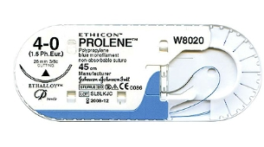
Tasks:
Carefully observe the picture and answer the following questions

- What are its characteristics 1.5
- What are its disadvantages to use 1.5

.....................................................................................................................................

Key: Static Station No 1

- It is non-absorbable synthetic monofilament suture, minimum tissue reaction and more stability. it has less stitch marks. 1.5
- It is expansive, difficult to handle and knotting 1.5

BDS Third Professional General Surgery
LAHORE MEDICAL & DENTAL COLLEGE LAHORE
Annual Examination 2018
Objectively Structured Performance Evaluation (OSPE )
Static Station No 1
Marks: 03 Time Allowed: 03 min
For Organizer:
Requirements:

1.Response sheet 2.pen/ball point 3. Table 4. Chair / stool

Topic Specification: Sutures

.......................................................................................................................................

Static Station No 1
Marks:03 Time Allowed: 03 min
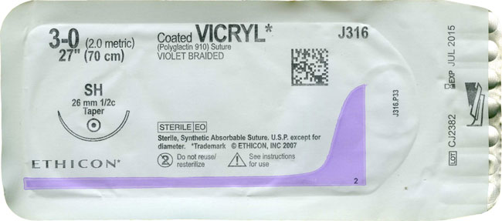
For Candidate:

Tasks:
Carefully observe the picture and answer the following questions

- What are its characteristics 1
- What are its disadvantages to use 1
- How it is absorbed in the body 1

......................................................................................................................................

Key: Static Station No 1

- It is absorbable synthetic braided suture, minimum tissue reaction and more stability. 1
- It is expansive, difficult to handle and knotting 1
- It is absorbed by the process of hydrolysis 1

