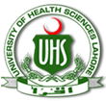
BDS Third Professional General Surgery
LAHORE MEDICAL & DENTAL COLLEGE LAHORE
Annual Examination 2018
Objectively Structured Performance Evaluation (OSPE )
Static Station No 3
Marks: 03 Time Allowed: 03 min
For Organizer:
Requirements:

1.Response sheet 2.pen/ball point 3. Table 4. Chair / stool

Topic Specification: Radiograph

.......................................................................................................................................

Static Station No 3
Marks:03 Time Allowed: 03 min
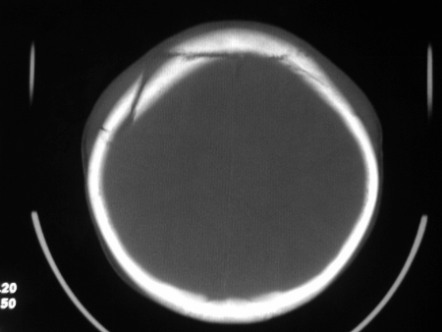
For Candidate:

Tasks:

Carefully observe the picture and answer the following questions

- What is this investigation 1
- What is finding 1
- What complications can occur due to this finding 1

......................................................................................................................................

Key: Static Station No 3

- CT scan Skull 1
- It shows the fracture of skull 1
- Infection, bleeding leading to subdural or extradural hematoma , cerebral contusions. 1

BDS Third Professional General Surgery
LAHORE MEDICAL & DENTAL COLLEGE LAHORE
Annual Examination 2018
Objectively Structured Performance Evaluation (OSPE )
Static Station No 3
Marks: 03 Time Allowed: 03 min
For Organizer:
Requirements:

1.Response sheet 2.pen/ball point 3. Table 4. Chair / stool

Topic Specification: Radiograph

......................................................................................................................................

Static Station No 3
Marks:03 Time Allowed: 03 min
For Candidate:

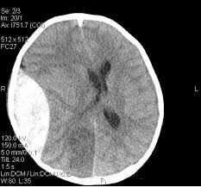
Tasks:

A 24 years old male got head trauma in an accident . Here is the CT scan of this patient

- What is the diagnosis 1
- What is pathogenesis in this condition 1
- What is treatment 1

.......................................................................................................................................

Key: Static Station No 3

- Extradural Hematoma 1
- Usually middle meningeal artery ruptures and causes hematoma which increase the intracranial pressure and damage to neural tissue 1
- Making burr hole or craniotomy to evacuate hematoma in emergency 1

BDS Third Professional General Surgery
LAHORE MEDICAL & DENTAL COLLEGE LAHORE
Annual Examination 2018
Objectively Structured Performance Evaluation (OSPE )
Static Station No 3
Marks: 03 Time Allowed: 03 min
For Organizer:
Requirements:

1.Response sheet 2.pen/ball point 3. Table 4. Chair / stool

Topic Specification: Radiograph

.......................................................................................................................................

Static Station No 3
Marks:03 Time Allowed: 03 min
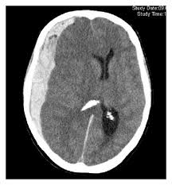
For Candidate:

Tasks:

A 24 years old male got head trauma in an accident . Here is the CT scan of this patient

- What is the diagnosis 1
- What clinical signs are expected 1
- What is treatment 1

.......................................................................................................................................

Key: Static Station No 3

- Subdural Hematoma
- Headache, Confusion, Change in behavior, Dizziness,Nausea and vomiting,Weakness,Apathy, Seizures
- Burr hole trephination, craniotomy, craniectomy

