OSPE
SURGERY
3rd Professional BDS
Surgical Unit-II, Lahore Medical & Dental College, Lahore

Interactive Station
(Counseling)
Time Allowed: 03 minutes

A 35 years old lady is suffering from Grave’s disease (exophthalmic goitre). How would you counsel her on her treatment regarding following questions?

- What are different treatment options available for this disease? 1
- What postoperative complications can occur as regards the functions of thyroid & parathyroid gland? 1
- How would you treat postoperative hypothyroidism? 1
…………………………………………………………………………………………………

Key
1. 1
a. Anti thyroid drugs
b. Surgery
c. Radioiodine
2. 1
a. Recurrence
b. Hypothyroidism
c. Hypoparathyroidism
3. By administering thyroxine orally 1
OSPE
SURGERY
3rd Professional BDS
Surgical Unit-II, Lahore Medical & Dental College, Lahore

Static Station
(Preoperative care)
Time Allowed: 03 minutes

A 55 years gentleman is suffering from dysphagia due to carcinoma of esophagus. He is scheduled for esophagectomy after 21 days.

  - What investigation would you request to assess the nutritional status of this patient? 1
  - What methods you can adopt to improve his nutritional status? 1
  - How would you improve his pulmonary functions? 1

………………………………………………………………………………..
Key

  - Lymphocytes count 0.25
  - Upper arm circumference 0.25
  - Triceps skin fold measurement 0.25
  - Serum albumin 0.25
- Total parenteal nutrition (TPN) 1

- Give up smoking 0.5
- Chest physiotherapy 0.5
OSPE
SURGERY
3rd Professional BDS
Surgical Unit-II, Lahore Medical & Dental College, Lahore

Interactive Station
(Postoperative care)
Time Allowed: 03 minuets

Emergency tracheostomy has been performed in a patient for laryngeal trauma and double lumen metallic tracheostomy tube has been placed.

1. How would you ensure a patent inner tube? 1
2. How would you ensure humidification of the inspired air? 1
3. How would you prevent displacement of the tracheostomy tube? 1

………………………………………………………………………………………………….

Key

- Frequent (half hourly) washing of the inner tube in soda bicarb solution 1
- By use of an air humidifier OR replacing a soaked gauze over the tracheostomy. 1
- By paying attention to the position of the tracheostomy tube & the anchoring ribbons OR stitches. 1
OSPE
SURGERY
3rd Professional BDS
Surgical Unit-II, Lahore Medical & Dental College, Lahore

Static Station
Time Allowed: 03 minuets
Carefully observe the provided radiograph and answer the following questions.

A 29-year-old male motorist is involved in a road traffic accident and suffers Right-sided blunt chest trauma.
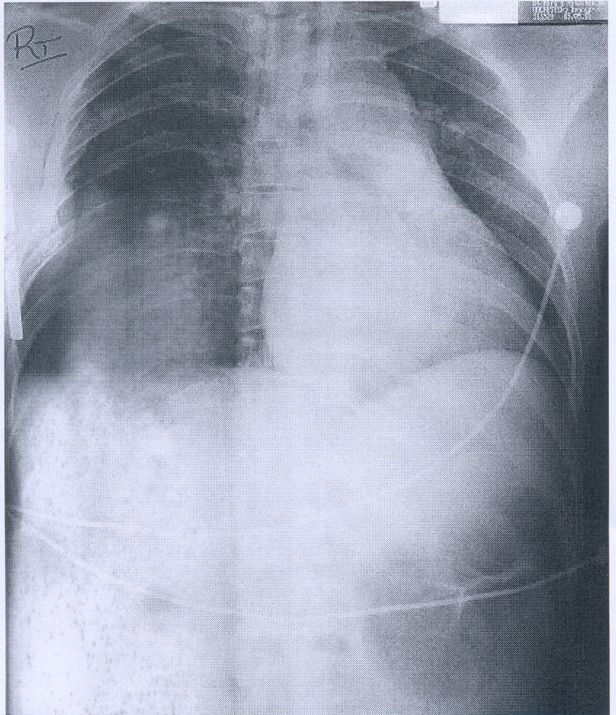

1. What are the radiological findings? 1
2. What is the diagnosis? 1
3. What emergency treatment is required at this stage? 1
………………………………………………………………………………………………………..
Key
1. (a) Double fractures of the ribs.
(b) Pneumothorax with mediastinal shift to the left.
2. Flail chest and tension Pneumothorax.
3. Tension! Pneumothorax requires immediate thoracocentesis by insertion of a large bore-drip cannula, and when the tension is relieved, only then should X-rays be taken before chest drain insertion.
OSPE
SURGERY
3rd Professional BDS
Surgical Unit-II, Lahore Medical & Dental College, Lahore

Static Station
Time Allowed: 03 minuets
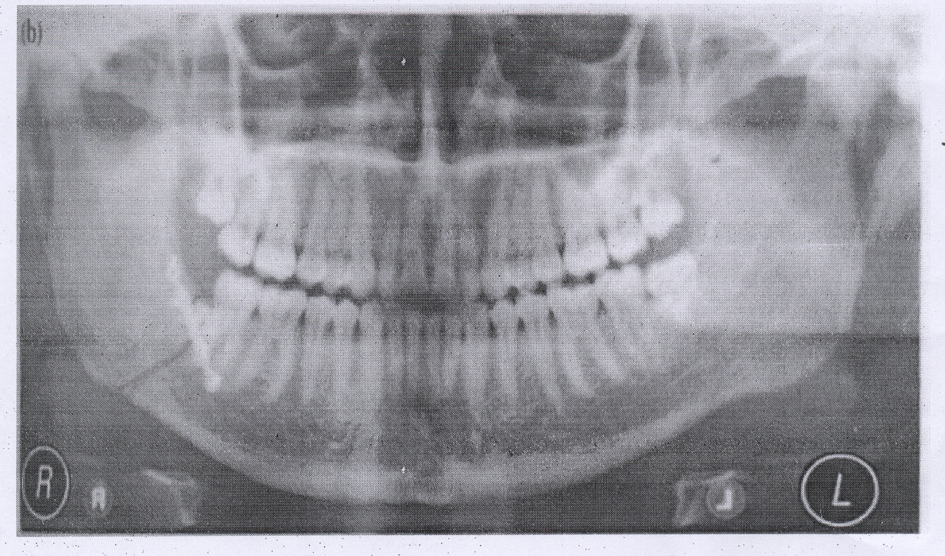
1
1. What are the findings?
2. What is the common site of fracture mandible?
3. Classify fracture mandible.

…………………………………………………………………….

Key

1. Fracture angle of mandible on right side
2. Neck of the mandible
3.
- Neck of condyle
- Angle of mandible
- Body of mandible
OSPE

SURGERY
3rd Professional BDS
Surgical Unit-II, Lahore Medical & Dental College, Lahore

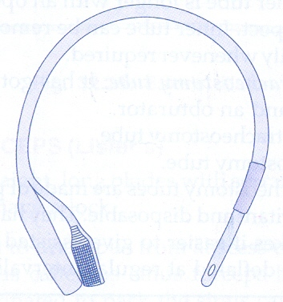
Static Station Time Allowed: 03

1. Identify given object.
2. Give its different parts.
3. Give indications of its use
4. Give complications of its use.

………………………………………………………………………………………………

Key

1. Foley's Catheter 0.5
2. Tip with opening, balloon for distilled water, two ways-(one for drainage and other for balloon dilation) 1.5
3. 1.5
  - To monitor urinary output
  - To relieve urinary bladder outflow obstruction
  - To collect urine in unconscious & paraplegic patients
4. 1.5
  - Infection
  - Injury to urethra
OSPE
SURGERY
3rd Professional BDS
Surgical Unit-II, Lahore Medical & Dental College, Lahore

Static Station
Time Allowed: 03 minuets

Carefully observed object and answer the following question.
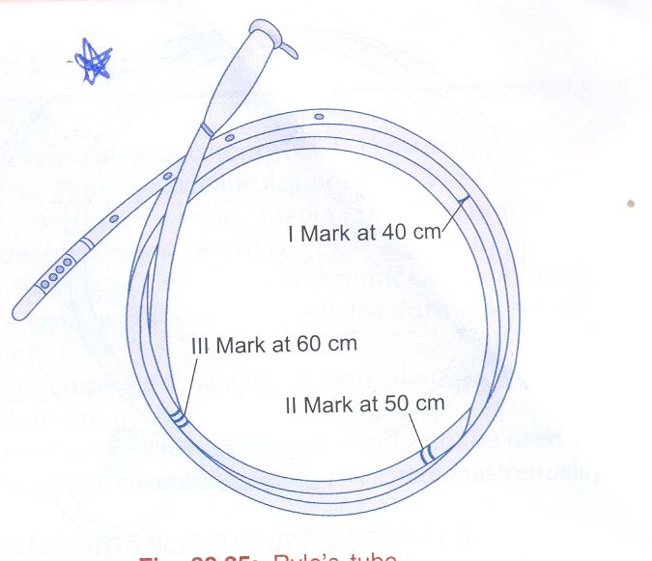

1. Identify
2. What do the marks indicate?
3. What are the complications?
4. How it is sterilized?

……………………………………………………………………….

Key

1. Nasogastric tube
2. Marks indicate distance of the tip from inciser teeth
3.
a. Perforation
b. Haemorrhage
c. Otitis media
4. Gamma radiations
OSPE
SURGERY
3rd Professional BDS
Surgical Unit-II, Lahore Medical & Dental College, Lahore

Static Station Time Allowed: 3 minuets
Carefully observe the diagram and answer the following questions.

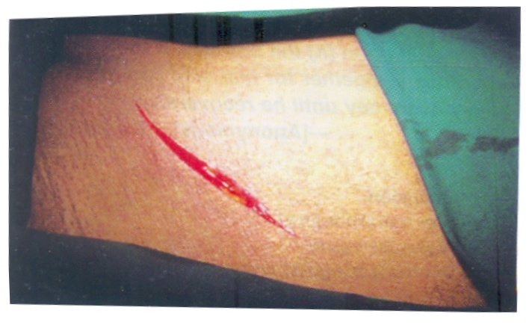

1. What is this type of wound?
2. What are different types of wound healing?
3. Give three factors that promote wound healing?
4. Give three factors that delay wound healing?

Key
1. Incised wound
2. a. First intention healing
b. Second intention healing
3. a. Good blood supply
b. Good nutrition
c. Vitamin C
4.
a. Anemia
b. Infection
c. Foreign body

OSPE
SURGERY
3rd Professional BDS
Surgical Unit-II, Lahore Medical & Dental College, Lahore

Static Station Time Allowed: 3 minuets

Carefully read the scenario and answer the examiners questions

A 20 years old man got facial & chest trauma his voice is normal. Pulse is 120/min & B.P 80/60 mmHg. On chest examination air entry is absent on right side of chest.
- What is most likely diagnosis?
- Define Shock.
- What are types of haemorrhage?
- What is the treatment ofhaemothorax pneumothorax?
- What are the signs of tension pneumothorax?
…………………………………………………………………………………………………………..

Key
1. Pneumothorax with hypovolumic shock
2. Shock is defined as poor tissue perfusion with impaired cellular metabolism
due to loss of blood
3. Arterial, venous, capillary
Primary, Secondary & Tertiary Haemorrhage
External & Internal Haemorrhage
4. Chest drain insertion
5. Engorged neck veins
Decreased air entry on effecter side Trachea shifted to opposite side

OSPE
SURGERY
Surgical Unit-II, Lahore Medical & Dental College, Lahore

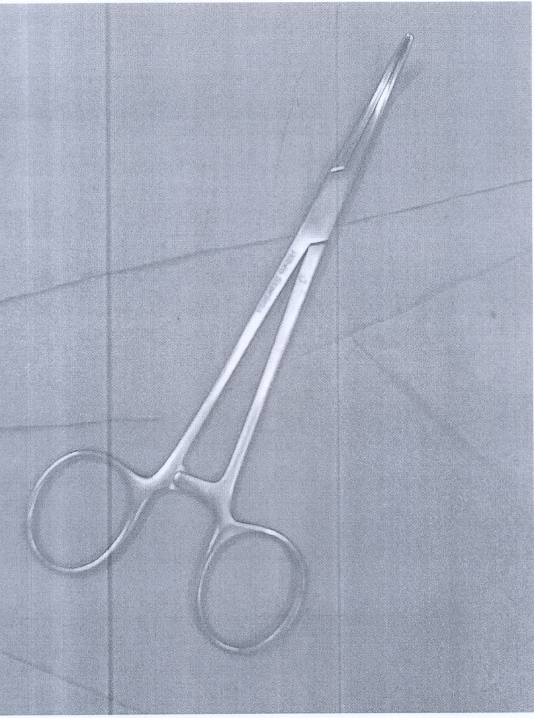
Static Station Time Allowed: 05 minuets

- What is this instrument?
- What are its Uses?
- How it is sterilized?
- What are different types of Haemorrhage?

…

1. Artery forcep
2.
- For hemostasis
- To hold aponeurosis or peritoneal
3. Autoclave
4.
- Primary haemorrhage
- Reactionary
- Secondary
OSPE
SURGERY
3rd Professional BDS
Surgical Unit-II, Lahore Medical & Dental College, Lahore

Static Station Time Allowed: 05 minuets
Carefully observed given diagram and answer the following question.

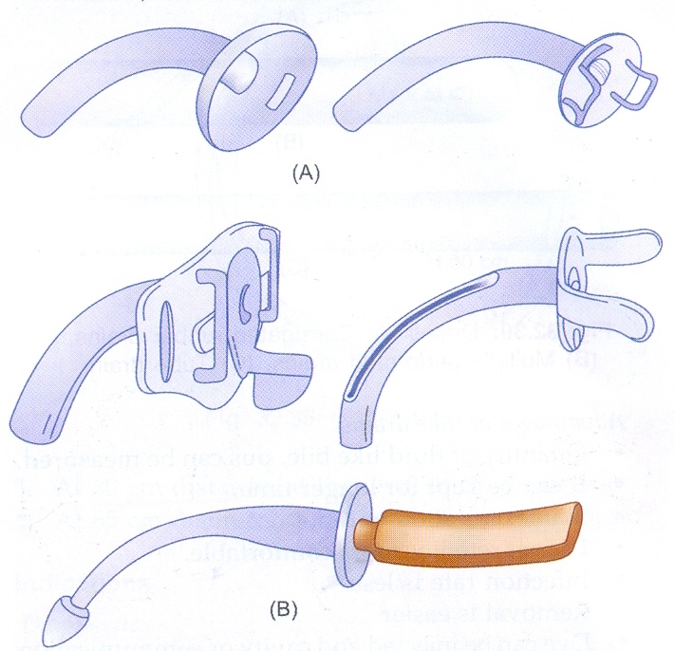

- What this instrument set is called? 1

- What are indications of use of this instrument set?

- What are complications of tracheostomy?

- What is the care of tracheostomy?

………………………………………………………………………………

- Tracheostomy Set
- Upper airway obstruction
To reduce dead space
As preliminary to certain operations

3. Haemorrhage
Pneumothorax
Tracheal stenosis

- Humidification
- Tracheo-bronchial toilet

