Static Station (1001)
Carefully observe the photograph of this object and answer the following questions
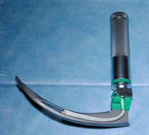
- What is the name of this object 1
B) What are the indications of its use 2

…………………………………………………………………………………………………………………………….

Key (1001)

- Laryngoscope 1
- 1) To perform direct laryngoscopy for suction of oropharynx 2
2) To pass endotracheal tube with the help of this instrument

Static Station (1002)

Carefully read and answer the following question
What are the indications of the endotracheal tube intubation?

………………………………………………………………………………………………………………….

Key (1002)
- Apnea
- Airway obstruction
- Facial injury
- Unconscious ,GCS less than 8
- Chest wall injury
- Persistent hypotension

Static Station (1003)

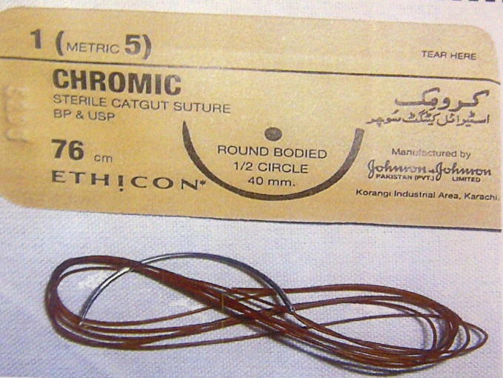

Carefully examine the photograph and answer the questions
- Identify this suture and its use
- What are advantages
- What are disadvantages

…………………………………………………………………………………………………………………………….

Key (1003)
- Chromic catgut
- Cheep
Easily absorbable
- Reactive Infection

Static station (1004)

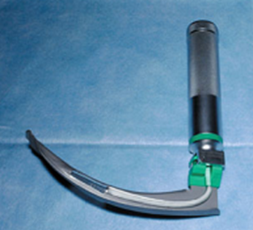

Carefully examine the given instrument and answer the following questions
- Identify the instrument in picture
- Give its uses

……………………………………………………………………………………………………………………………..

Key (1004)
- Macintosh laryngoscope
- It aids in putting down endotracheal tube
Visualize vocal cords
Helps in removal of foreign bodies from oropharynx

Static Station (1005)

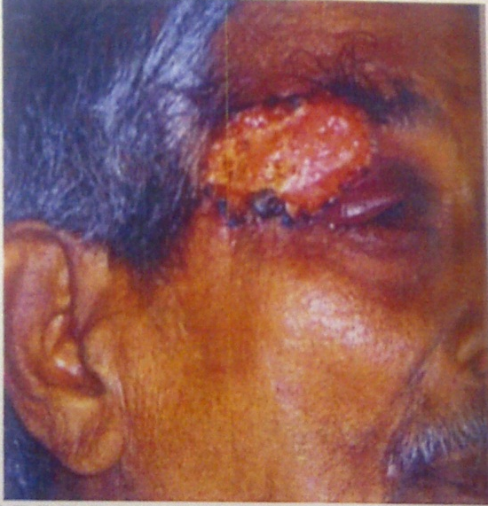

Carefully observe the photograph and answer the following questions

- What is your diagnosis 01
- What is treatment 01
- Can it reoccur 01
…………………………………………………………………………………………………………………………….

Key (1005)

- It is basal cell carcinoma
- Wide local excision with split skin grafting or flap rotation
- Recurrence is rare .It is locally malignant tumor
Static Station (1006)

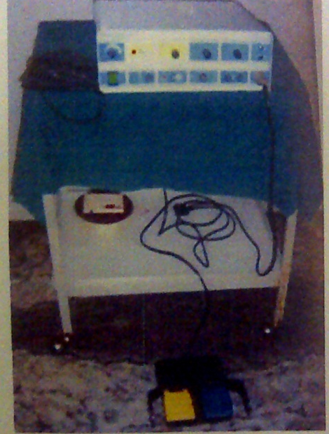
Carefully examine the given instrument and answer the following questions
- Identify the machine in picture
- What are its uses

………………………………………………………………………………………………………………………………….

Key (1006)

- Diathermy machine
- Coagulations of bleeder to achieve hemostasis
Cutting of muscles and facia
Small skin lesions like warts and corns are removed

Static Station (1007)

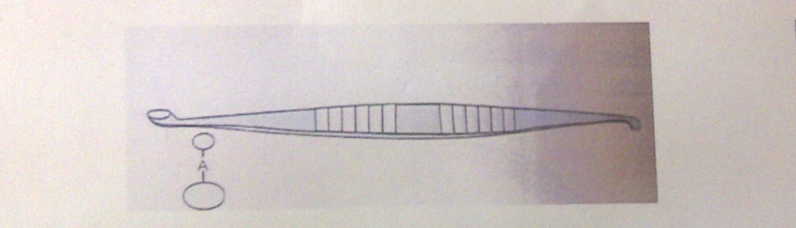

Carefully examine the given instrument and answer the following questions
- Identify the instrument in picture 01
- What are its uses 01
- How it is sterilized 01

……………………………………………………………………………………………………………………………….

Key (1007)
- Volkmann’s scoop (curette )
- It is used to curret granulation tissue ,ulcer bed and sinus cavity
- By autoclave

Static station (1008)
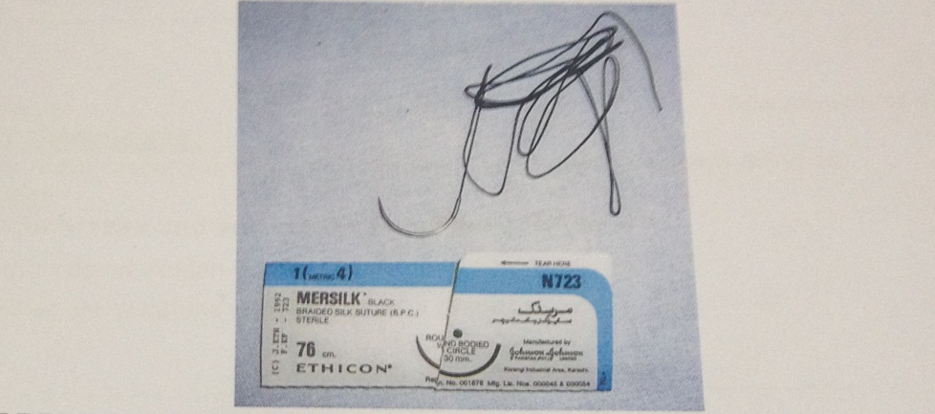

Carefully observe the photograph and answer the questions
- Identify the suture in picture
- Give any two advantages
- What are disadvantages

………………………………………………………………………………………………………………………………..

Key (1008)
- Silk
- Non absorbable
Good handling and knotting
- Reactive
Infection
Static station (1009)

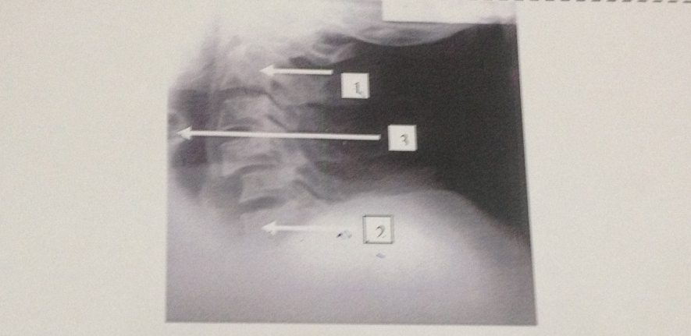
2
3
1
Carefully examine the given radiograph of neck lateral view and answer the following questions
Label the structures 1,2and 3

………………………………………………………………………………………………………………………………

Key (1009)
- 2nd cervical vertebra
- 7th cervical vertebra
- Tracheal shadow

Static Station (1010)
Carefully observe the photograph of this object and answer the following questions

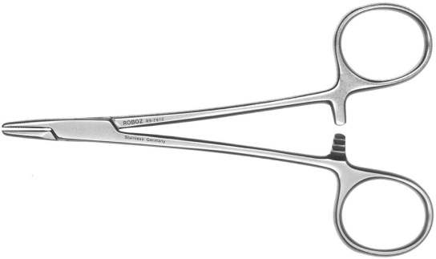
- Identify this instrument
- What is its clinical use
- How it is sterilized

_____________________________________________________________________________________

Key (1010)

- Needle holder
- To suture the wound by holding needle with it.
- By autoclave method.

Interactive Station( 1011)

A young patient presented with swelling in front of neck. On examination it is Multinodular. Answer the following questions.

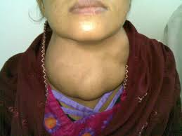

- What are treatment options 0.5
- What are hazards of this operation 1.0
- Will there be change of voice after operation 0.5
- Will she take medicine after operation 0.5
- Will she need blood transfusion during operation 0.5
……………………………………………………………………………………………………………

Key (1011)
- Near total or total thyroidectomy
- Bleeding , hoarseness of voice , hypocalcaemia, hypothyroidism
- Yes
- Yes
- May be

