Third professional BDS
General Surgery OSPE
Annual Examination(2019)
LMDC Lahore

Marks:3. Time Allowed: 3 min

Static Station No 9

Topic Specification: Drains/sutures/catheter

- What are the two divisions of surgical sutures? 01
- What do you mean by tensile strength of suture? 01
- Which suture has best holding? 01

Key 9

- Absorbable and nonabsorbable 0.5+0.5
- It means the strength by which it keeps tissue together 01
- Braided suture( silk) 01

Third professional BDS
General Surgery OSPE
Annual Examination(2019)
LMDC Lahore

Marks:3. Time Allowed: 3 min

Static Station No 9

Topic Specification: Drains/sutures/catheter

- Which material is used for its manufacture? 01
- How this suture is degraded in the body 01
- What are its disadvantages 01

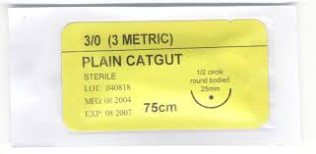

Key 9

- Intestine of cattle or sheep 01
- By proteolysis 01
- Rejection, stich abscess, sensitivity reaction 01

Third professional BDS
General Surgery OSPE
Annual Examination(2019)
LMDC Lahore

Marks:3. Time Allowed: 3 min

Static Station No 9

Topic Specification: Drains/sutures/catheter

Identify this object and answer the following questions

- What are its main uses? 01
- Name its different parts 01
- What complications can occur in its use 01

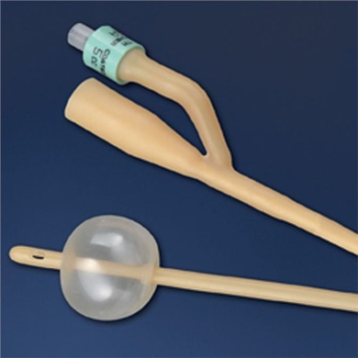

Key 9

- Acute and chronic retention of urine, to measure urine output 0.5+.05
- Tip, balloon, connecter, water injecting channel 01
- Bleeding , urethral injury, infection, stricture 01

Third professional BDS
General Surgery OSPE
Annual Examination(2019)
LMDC Lahore

Marks:3. Time Allowed: 3 min

Static Station No 9

Topic Specification: Drains/sutures/catheter

- Identify this catheter 01
- Name two veins which are commonly used for insertion 01
- What complications can occur during procedure 01

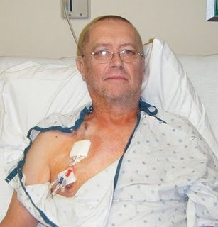

KEY 9

- Central venous catheter 01
- Internal jugular , subclavian veins 01
- Rupture of vein, pneumothorax, hemothorax, air embolism 01

Third professional BDS
General Surgery OSPE
Supplementary Examination(2020)
LMDC Lahore

Marks:3. Time Allowed: 3 min

Static Station No 9

Topic Specification: Drains/sutures/catheter

- Identify this drain. 01
- Name some procedures in the neck where it is used. 01
- How it is sterilized 01

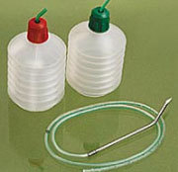

Key 9

- Redivac suction drain 01
- Thyroidectomy, parotidectomy, Neck dissections 01
- By gamma radiations 01

Third professional BDS
General Surgery OSPE
Annual Examination(2019)
LMDC Lahore

Marks:3. Time Allowed: 3 min

Static Station No 8

Topic Specification: Radiograph

A 24 years old motorcyclist got trauma to face. Here is the radiograph. Answer the following questions.

- What are the findings on this radiograph? 01
- Enlist the steps to manage this patient 02

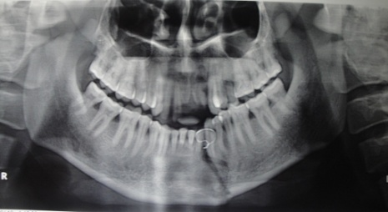

Key 8

- Fracture of body of mandible 01
- Admit the patient, initial resuscitation and evaluation according to ATLS protocol. Local examination including neurological assessment .Get further imaging like CT scan if needed. Reduction and fixation of fracture site according to fracture type. Analgesic and antibiotics. Follow up patient for complication and out come of procedure. 02

Third professional BDS
General Surgery OSPE
Annual Examination(2019)
LMDC Lahore

Marks:3. Time Allowed: 3 min

Static Station No 8

Topic Specification: Radiograph

A 30 years old man got fracture of mandible and following photograph is taken during procedure.

- What is the commonest site of fracture? 01
- What procedure is going on in this photograph 01
- What is the name of this plate? 01

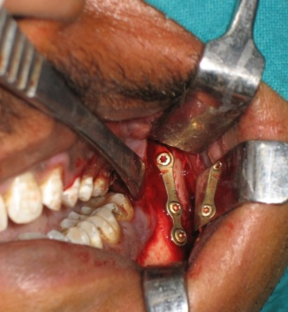

Key8

- The neck of condyle mandible 01
- ORIF ( open reduction and internal fixation). 01
- Miniplates 01

Third professional BDS
General Surgery OSPE
Annual Examination(2019)
LMDC Lahore

Marks:3. Time Allowed: 3 min

Static Station No 8

Topic Specification: Radiograph

An 18 years old boy got head injury during road traffic accident. There is history of loss of consciousness. After initial resuscitation the following investigation was done.
- What is this investigation 01
- What is the finding and diagnosis? 01
- What surgical procedure is needed to treat it? 01

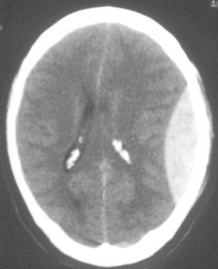

Key 8

- CT scan Brain 01
- Biconvex hyper density ( Epidural Hematoma ) 01
- Evacuation of hematoma 01

Third professional BDS
General Surgery OSPE
Annual Examination(2019)
LMDC Lahore

Marks:3. Time Allowed: 3 min

Static Station No 8

Topic Specification: Radiograph

A 40 years old man got sever head trauma in road traffic accident. Here is the CT scan Brain of this patient.

- What is the finding on this scan and diagnosis? 01
- What is the cause of this finding? 01
- What treatment is done 01

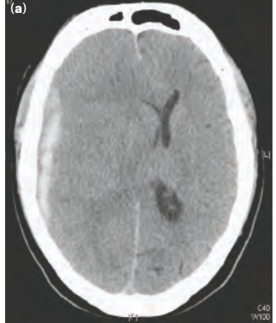

Key 8

- Concave hyperdensity , midline shift ( subdural hematoma). 01
- This is due to injury of the cortical vessels of brain 01
- Evacuation of hematoma by craniotomy or craniectomy 01

Third professional BDS
General Surgery OSPE
Supplementary Examination(2020)
LMDC Lahore

Marks:3. Time Allowed: 3 min

Static Station No 8

Topic Specification: Radiograph

Identify this radiograph and answer the following questions

- What is finding 01
- What complication can 02

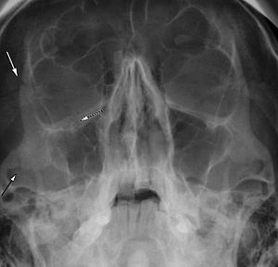

Key 8

- Zygomaticomaxillary complex fracture. 01
- loss of cheek projection with increased width of the face. there is loss of sensation in the cheek and upper lip due to infraorbital nerve injury. Facial bruising, periorbital ecchymosis, soft tissue gas, swelling, trismus, altered mastication, diplopia and ophthalmoplegia are other indirect features of the injury. 02

Third professional BDS
General Surgery OSPE
Annual Examination(2019)
LMDC Lahore

Marks:3. Time Allowed: 3 min

Static Station No 7

Topic Specification: Radiograph

A 38 years old man got chest trauma. Here is his chest radiograph

- What is the finding 01
- What complications can occur 01
- How will you manage him? 01

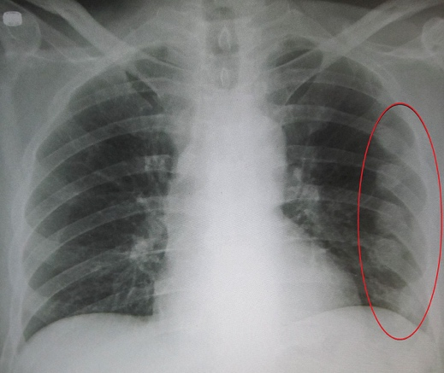

Key 7

- Fractures of multiple ribs. 01
- Pneumothorax, hemothorax, surgical emphysema 01
- After resuscitation and assessment according to ATLS protocol. Oxygen inhalation , intercostal blocks for local pain, analgesics and antibiotics 01

Third professional BDS
General Surgery OSPE
Annual Examination(2019)
LMDC Lahore

Marks:3. Time Allowed: 3 min

Static Station No 7

Topic Specification: Radiograph

A 40 years old man presented in emergency room with dyspnea after chest trauma in a fall from roof.

- What is the diagnosis on this radiograph? 01
- What is the immediate treatment 02

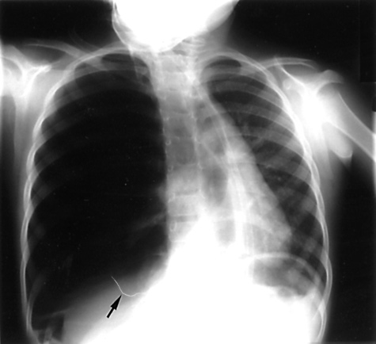

Key 7

- Pneumothorax right side with shift of mediastinum to opposite side 01
- Insertion of wide bore needle in 2nd intercostal space then tube thoracostomy 02

Third professional BDS
General Surgery OSPE
Annual Examination(2019)
LMDC Lahore

Marks:3. Time Allowed: 3 min

Static Station No 7

Topic Specification: Radiograph

A 22 years old male got injury to cervical spine in a road traffic accident. Please observe the following radiograph and answer questions

- What is finding. 01
- Which complication can occur? 01
- What is the most important step is taken before transfer of patient to hospital?
01
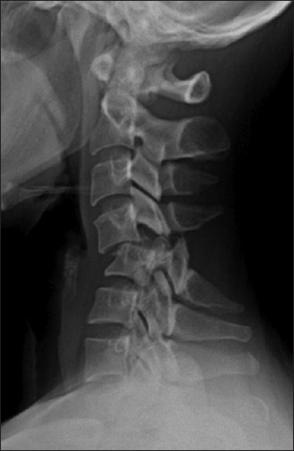

Key 7

- Fracture cervical spine at level 3 &4. 01
- Quadriplegia 01
- Stabilization of cervical spine with collar on rigid board 01

Third professional BDS
General Surgery OSPE
Annual Examination(2019)
LMDC Lahore

Marks:3. Time Allowed: 3 min

Static Station No 7

Topic Specification: Radiograph

A young man got trauma in a car accident .

- What is this type of fracture? 01
- What is mechanism of injury 01
- How it can be prevented 01

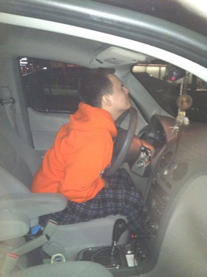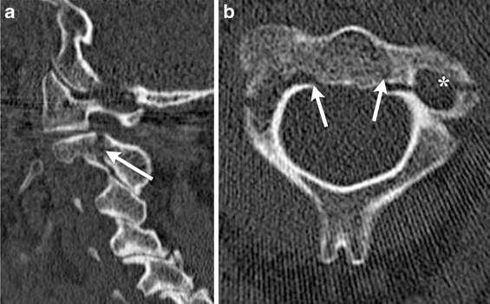

Key 7

- Hangman’s fracture C2. 01
- Hyperextension of neck 01
- By wearing seat belts 01

Third professional BDS
General Surgery OSPE
Supplementary Examination(2020)
LMDC Lahore

Marks:3. Time Allowed: 3 min

Static Station No 7

Topic Specification: Radiograph

A 45 years old man got penetrating chest trauma in a shotgun by robber

- What is the finding on radiograph? 01
- What are the aims of emergency thoracotomy? 02

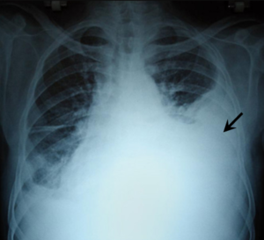

Key 7

- Hemothorax on left side
- internal cardiac massage, control of haemorrhage from injury to the heart or lung, control of intrathoracic haemorrhage from other sources, control of massive air leak

Third professional BDS
General Surgery OSPE
Annual Examination(2019)
LMDC Lahore

Marks:3. Time Allowed: 3 min

Static Station No 6

Topic Specification: Tubing

A young female underwent exploratory laparotomy for enteric perforation. Carefully observe the photograph and answer questions.

- What is the name of this tube? 01
- What are its common uses? 01
- How will you confirm that it is proper place? 01

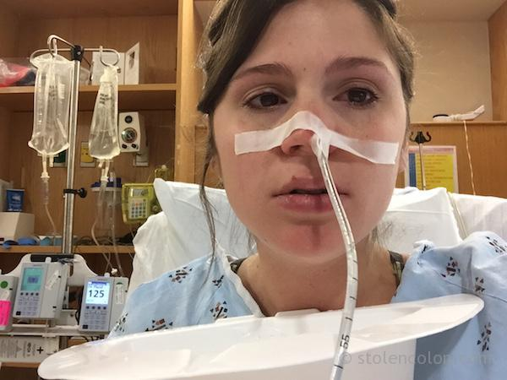

Key 6

- Nasogastric tube 01
- Aspiration of stomach contents, for feeding purposes 01
- By injecting are in to tube and listening gurgling sound, radiograph 01

Third professional BDS
General Surgery OSPE
Annual Examination(2019)
LMDC Lahore

Marks:3. Time Allowed: 3 min

Static Station No 6

Topic Specification: Tubing

An old person has advanced carcinoma of esophagus. He is unable to take anything by mouth. The gastroenterologist has inserted this tube for feeding.

- What is the name of this procedure 01
- What complications can occur during the procedure 02
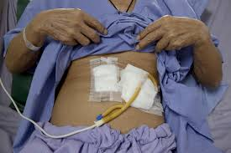

Key 6

- Percutaneous endoscopic gastrostomy ( PEG). 01
- Bleeding, Perforation, Peritonitis , infection, gastric ulcer, gastrocolic fistula 02

Third professional BDS
General Surgery OSPE
Annual Examination(2019)
LMDC Lahore

Marks:3. Time Allowed: 3 min

Static Station No 6

Topic Specification: Tubing

- What is this tube and bottle? 01
- What are its main indications? 01
- What complications can occur 01

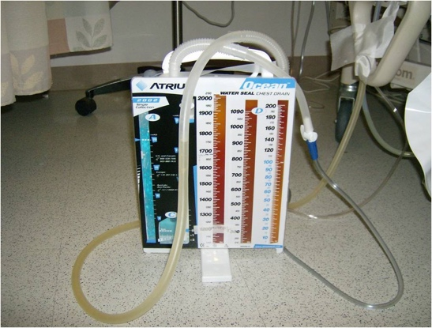

Key 6

- Chest tube with underwater seal bottle 01
- Pneumothorax and hemothorax, pleural effusion and empyema thoracic 01
- Infection , bleeding, injury to lung, emphysema 01

Third professional BDS
General Surgery OSPE
Annual Examination(2019)
LMDC Lahore

Marks:3. Time Allowed: 3 min

Static Station No 6

Topic Specification: Tubing

Identify these objects and answer following questions

- Which size is commonly used during hypovolemic shock? 01
- What complications can occur for its use 01
- What are common veins used for its insertion 01

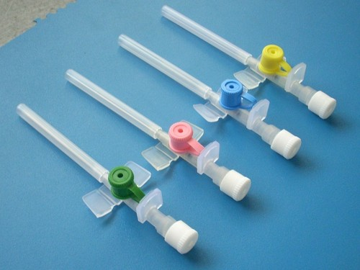

Key 6

- 14 G. 01
- Phlebitis, cellulitis, air embolism 01
- Dorsum hand, cephalic and basilic veins 01

Third professional BDS
General Surgery OSPE
Supplementary Examination(2020)
LMDC Lahore

Marks:3. Time Allowed: 3 min

Static Station No 6

Topic Specification: Tubing

Carefully observe this tubing and answer following questions

- Identify this object 01
- What is its use 01
- How it is sterilized 01

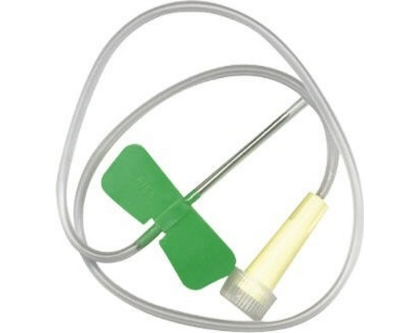

Key 6
- Butterfly iv canula 01
- For bolus injection 01
- By gamma radiations 01

Third professional BDS
General Surgery OSPE
Annual Examination(2019)
LMDC Lahore

Marks:3. Time Allowed: 3 min

Static Station No 5

Topic Specification: instrument

Carefully observe this instrument and answer the following question.
- Identify this instrument 01
- What are its common uses ? 01
- How it is sterilized 01

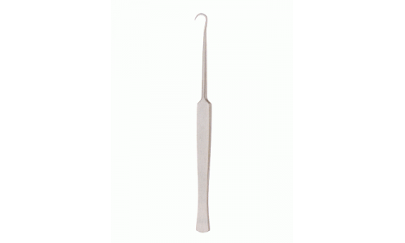

Key 5

- Hook retractor 01
- 1)To retract skin edges during excision of sebaceous cyst and lipoma. 2)To retract the skin during venesection.3)To retract tough fascia. 01
- By autoclaving 01

Third professional BDS
General Surgery OSPE
Annual Examination(2019)
LMDC Lahore

Marks:3. Time Allowed: 3 min

Static Station No 5

Topic Specification: instrument

Carefully observe this instrument and answer the following questions
- Identify this instrument 01
- What are its uses. 01
- How it is sterilized 01
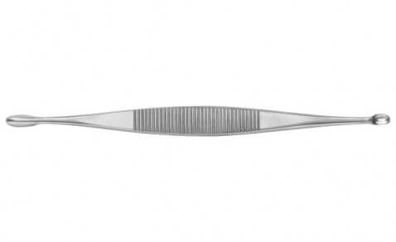

Key5

- Volkmann's scoop or curate 01
- Used to curette a chronic abscess either in bone or the soft tissue. May be used to curette a sinus or fistulous tract. 01
- By autoclaving 01

Third professional BDS
General Surgery OSPE
Annual Examination(2019)
LMDC Lahore

Marks:3. Time Allowed: 3 min

Static Station No 5

Topic Specification: instrument

Carefully observe this instrument and answer the following questions.
- Identify this instrument 01
- What are its uses 01
- How it is sterilized 01

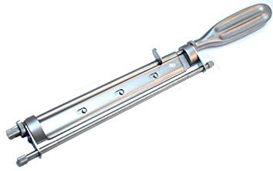

Key 5
- Humby skin grafting knife 01
- It is used for taking the split skin graft 01
- By autoclaving 01

Third professional BDS
General Surgery OSPE
Annual Examination(2019)
LMDC Lahore

Marks:3. Time Allowed: 3 min

Static Station No 5

Topic Specification: instrument

Carefully observe this instrument and answer the following questions.
- Identify this instrument 01
- What are its uses 01
- How it is sterilized 01

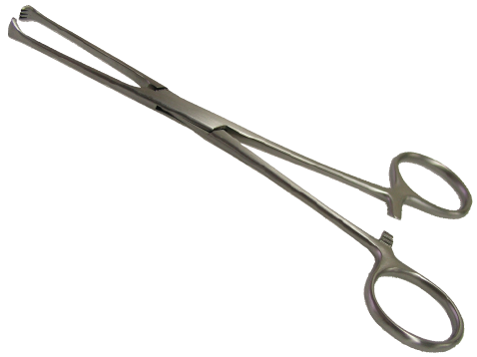

Key 5
- Allis’ tissue forceps 01
- To hold thin and tough structures, e.g. subcutaneous tissue, deep fascia, rectus sheath, etc. for giving traction. To hold fibrous capsule of a structure. 01
- By autoclaving 01

Third professional BDS
General Surgery OSPE
Supplementary Examination(2020)
LMDC Lahore

Marks:3. Time Allowed: 3 min

Static Station No 5

Topic Specification: instrument

Carefully observe this instrument and answer the following questions.
- Identify this instrument 01
- What are its uses 01
- How it is sterilized 01

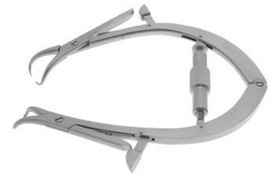

Key 5
- Jolls’ thyroid retractor 01
- It is used to retract flaps during thyroidectomy 01
- By autoclaving 01

Third professional BDS
General Surgery OSPE
Annual Examination(2019)
LMDC Lahore

Marks:3. Time Allowed: 3 min

Static Station No 4

Topic Specification: Postoperative care

A 38 years old man underwent superficial parotidectomy for pleomorphic adenoma. He complains of gustatory sweating.
- Which complication has occur? 01
- What is cause of this complication ? 01
- What are treatment options 01

Key 4

- Freys’ syndrome 01
- It results from damage to the autonomic innervation of the salivary gland with inappropriate regeneration of the postganglionic parasympathetic nerve fibers of the auriculotemporal nerve that aberrantly stimulate the sweat glands of the overlying skin 01
- 1)antiperspirants, usually containing aluminum chlorid2) denervation by tympanic neurectomy 3) the injection of botulinum toxin into the affected skin. 01

Third professional BDS
General Surgery OSPE
Annual Examination(2019)
LMDC Lahore

Marks:3. Time Allowed: 3 min

Static Station No 4

Topic Specification: Postoperative care

A45 years old female underwent superficial parotidectomy. Postoperatively she presented with soft fluctuant swelling at surgical site.

- What is the possible complication 01
- Which investigation will help to diagnose 01
- How will to treat it 01

Key 4

- Seroma formation
- USG
- Repeated aspirations under USG guidance

Third professional BDS
General Surgery OSPE
Annual Examination(2019)
LMDC Lahore

Marks:3. Time Allowed: 3 min

Static Station No 4

Topic Specification: Postoperative care

A24 years old male underwent superficial parotidectomy for recurrent parotitis. Postoperatively he complains of watery discharge from wound site opening during meal time.
- Which complication has occurred 01
- Which investigations will help to diagnose it 02

Key 4

- Parotid fistula
- Fistulogram, MRI, Sialography

Third professional BDS
General Surgery OSPE
Annual Examination(2019)
LMDC Lahore

Marks:3. Time Allowed: 3 min

Static Station No 4

Topic Specification: Postoperative care

A 45 years old female underwent total thyroidectomy for thyroid cancer. On 2nd postoperative day she complains of numbness and tingling sensation on face

- Which complication is expected 01
- How will you confirm it 01
- How will you treat it 01

Key 4

- Injury to parathyroid glands leading to hypocalcemia 01
- Serum calcium level 01
- 10% calcium gluconate diluted in 10ml normal saline and infuse in 10 minutes very slowly. 01

Third professional BDS
General Surgery OSPE
Supplementary Examination(2020)
LMDC Lahore

Marks:3. Time Allowed: 3 min

Static Station No 4

Topic Specification: Postoperative care

A young male underwent excision of lipoma at left upper chest. After few months he presented with such scar seen in this photograph

- What is the differential diagnosis 01
- What options are available to treat it. 02

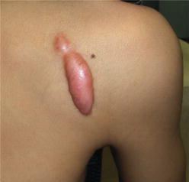

Key 4

- Keloid and hypertrophic scar 01
- Surgery, radiation, local corticosteroid tapes, intralesional steroids 02

Third professional BDS
General Surgery OSPE
Annual Examination(2019)
LMDC Lahore

Marks:3. Time Allowed: 3 min

Static Station No 3

Topic Specification: Preoperative care

A 32 years old female with diagnosis of toxic multinodular goiter is planned for total thyroidectomy. Answer the following questions regarding her preoperative assessment and preparation.
- How will you prepare her for surgery 01
- Which investigations are needed for anesthesia assessment 02

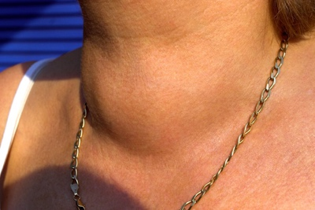

Key3

- Making the patient Euthyroid by giving beta blockers and Carbimazole orally 01
- Thyroid profile, ECG, Radiograph lower neck, indirect laryngoscopy 02

Third professional BDS
General Surgery OSPE
Annual Examination(2019)
LMDC Lahore

Marks:3. Time Allowed: 3 min

Static Station No 3

Topic Specification: Preoperative care

A 45 years old man is known diabetic and hypertensive presented with diabetic foot. He is on antihypertensive drugs and regular insulin. Debridement of wound is planned on elective list.

- What advice you will give to nurse on duty
- Ideally what should be his number on list

Key 4

- Omit the morning dose of insulin and give antihypertensive drugs with sip of water. Start infusion of dextrose water added with regular insulin and KCL. Monitor blood sugar 02
- Diabetic patient should be at first on list 01

Third professional BDS
General Surgery OSPE
Annual Examination(2019)
LMDC Lahore

Marks:3. Time Allowed: 3 min

Static Station No 3

Topic Specification: Preoperative care

A 50 years old HCV positive patient planned for excision of submandibular gland.

- What relevant investigations are needed 01
- Which universal precautions will be taken in the OT 02

Key 3

- LFT, Coagulation profile, USG abdomen, renal function profile 01

- Wear safety spectacles to protect eyes.
- Water proof gown to protect front and arms.
- Full boots to protect feet.
- Wear double pairs of gloves.
- Keep surgical assistants to a minimum.
- Sharp instruments should be passed from scrub nurse to the surgeon in a kidney tray to avoid injury
- Put used needles in puncture resistant containers and never try to replace them back in protective sheath. 02

Third professional BDS
General Surgery OSPE
Annual Examination(2019)
LMDC Lahore

Marks:3. Time Allowed: 3 min

Static Station No 3

Topic Specification: Preoperative care

A 55 years old man with mechanical heart valves is on warfarin therapy. He is planned for tooth extraction. How will you prepare him for this procedure. 03

Key3

In patients with mechanical heart valves, warfarin needs to be stopped for 5 days before surgery, and an infusion of unfractionated heparin started when the INR falls below 1.5. The activated partial thromboplastin time (APTT), should be monitored to keep it at 1.5 times normal and the infusion is then stopped 2 hours before surgery. Heparin and warfarin should be started in the postoperative period, and heparin is stopped when the full effect of warfarin takes effect. Prophylactic antibiotics is also given. 03

Third professional BDS
General Surgery OSPE
Supplementary Examination(2020)
LMDC Lahore

Marks:3. Time Allowed: 3 min

Static Station No 3

Topic Specification: Preoperative care

A 40-year-old diabetic male planed for elective surgery. His blood sugar is control on oral hypoglycemic drugs.

- How will you prepare this patient for surgery regarding his diabetes? 02
- What preoperative assessment is necessary in systemic evaluation? 01

Key 3

- I will stop oral hypoglycemic drugs 48 hours before surgery.
Blood sugar will be checked before surgery and (GKI) glucose-potassium-insulin infusion is considered if blood sugar is more than 200mg/dl.
All oral hypoglycemic can be started when the patient is eating normal. 02
- Cardiovascular status. 01

Third professional BDS
General Surgery OSPE
Annual Examination(2019)
LMDC Lahore

Marks:3. Time Allowed: 3 min

Static Station No 2

Topic Specification: Trauma/Emergency

A young female presents with swelling in the submental region. She complains sever pain in swelling and difficulty in breathing . on examination swelling is firm.

- What is possible diagnosis 01
- What are the precipitating factors 01
- How will you treat her 01

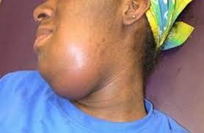

Key 2

- Ludwig's’ angina 0.5
- Caries teeth, Carcinoma oral cavity, Chronic sialadenitis (involving submandibular Chemotherapy 01
- Hospitalization and early use of parenteral antibiotics
If patient does not improve with conservative treatment, surgical drainage should be done.
Under GA or LA, a curved incision is given below the mandible to incise deep cervical fascia liberally. The mylohyoid muscle may also be incised to decompress the floor of mouth. Wound is irrigated and sutured loosely over subcutaneous drain. Rarely tracheostomy may be required in cases of laryngeal obstruction. 1.5

Third professional BDS
General Surgery OSPE
Annual Examination(2019)
LMDC Lahore

Marks:3. Time Allowed: 3 min

Static Station No 2

Topic Specification: Trauma/Emergency

A young boy presented in emergency room with severe dyspnea after chest trauma in a road traffic accident. On examination the breath sounds are absent on right side and neck veins are engorged.

- What is the first step in his management to save life 01
- What is your clinical diagnosis. 01
- What is definite treatment 01

Key2

- Insert wide bore canula in the 2nd intercostal space
- Tension pneumothorax
- Tube thoracostomy

Third professional BDS
General Surgery OSPE
Annual Examination(2019)
LMDC Lahore

Marks:3. Time Allowed: 3 min

Static Station No 2

Topic Specification: Trauma/Emergency

A child got lacerated wound in the forehead half an hour ago.

- How will you suture it. 1.5
- What postoperative complications can occur 1.5

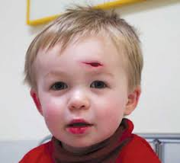

Key 2

- Primary closure with prolene suture under aseptic measure 1.5
- Hematoma, infection, abnormal scar. 1.5

Third professional BDS
General Surgery OSPE
Annual Examination(2019)
LMDC Lahore

Marks:3. Time Allowed: 3 min

Static Station No 2

Topic Specification: Trauma/Emergency

A 43 years old diabetic female presented with swelling on the left parotid region.
- What investigations are required confirm it 1.5
- Which precaution should be taken during incision making 1.5

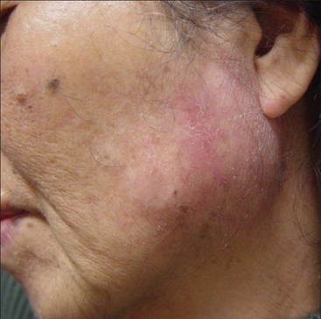

Key 2

- USG, MRI, CT scan. 1.5
- Make a Lazy S incision to save the branches of facial nerve 1.5

Third professional BDS
General Surgery OSPE
Supplementary Examination(2020)
LMDC Lahore

Marks:3. Time Allowed: 3 min

Static Station No 2

Topic Specification: Trauma/Emergency

A 20 years old motorcyclist got head injury in road traffic accident. In emergency he is unconscious. What are the points regarding assessment of eye opening response in Glasgow coma scale?

Key2

Eye-Opening Response

Spontaneous eye opening 4
Opens eyes to speech 3
Opens eyes to painful stimuli 2
No eye opening 1

Third professional BDS
General Surgery OSPE
Annual Examination(2019)
LMDC Lahore

Marks:3. Time Allowed: 3 min

Static Station No 1

Topic Specification: Trauma/Emergency

A 23 years old male got severe trauma to his face and head. On examination he is profusely bleeding from oral cavity. He is becoming cyanosed.

- How will you maintain his airway? 01
- What are the components of GCS? 02

Key 1

- Cricothyroidotomy 01
- Eye opening response, verbal response, motor response 02

Third professional BDS
General Surgery OSPE
Annual Examination(2019)
LMDC Lahore

Marks:3. Time Allowed: 3 min

Static Station No 1

Topic Specification: Trauma/Emergency

An 18-year-old man who was in a motor vehicle crash is brought to the emergency department. You are responsible for evaluating the patient's cervical spine.
What management is appropriate in wake and alert patient 03

Key 1

Cervical spine precautions include neck immobilization with a collar or a board. If no stabilization is in place, it is necessary to maintain in-line cervical
stabilization until the neck has been stabilized by one of these methods. 03

Third professional BDS
General Surgery OSPE
Annual Examination(2019)
LMDC Lahore

Marks:3. Time Allowed: 3 min

Static Station No 1

Topic Specification: Trauma/Emergency

You are evaluating a 38-year-old man in the emergency department. He has an isolated head injury and loss of consciousness.
What therapeutic measures warrant consideration during the evaluation? 03

Key 1

Measures that may lessen the amount of brain edema when the patient is first seen include elevation of the head to 30° and hyperventilation to a level of Pco 2 at 26 to 28 mmHg. Mannitol is also useful because it dehydrates the brain within 15-20 minutes, leading to decreased intracranial pressure.
Phenytoin (Dilantin) loading with continuation for at least 1 week to prevent seizures may be useful. Medications that depress central nervous system (CNS) function should be avoided during this phase of the evaluation. 03

Third professional BDS
General Surgery OSPE
Annual Examination(2019)
LMDC Lahore

Marks:3. Time Allowed: 3 min

Static Station No 1

Topic Specification: Trauma/Emergency

A 5 years old child got lacerated wound of tongue and lower lip. He has completed vaccination against tetanus.

- Write steps of management. 02
- Which anesthesia will be better 01

Key 1

- Admit the patient, prepare for Surgery (iv line, analgesia, antibiotics, booster dose of tetanus toxoid consent Base line investigations) General anesthesia, primary suturing of laceration with absorbable suture, observe for bleeding postoperatively. 02
- General anesthesia 01

Third professional BDS
General Surgery OSPE
Supplementary Examination(2020)
LMDC Lahore

Marks:3. Time Allowed: 3 min

Static Station No 1

Topic Specification: Trauma/Emergency

A one year old child got burn with boiling water. What is the criteria to manage the patient in burn center? 03

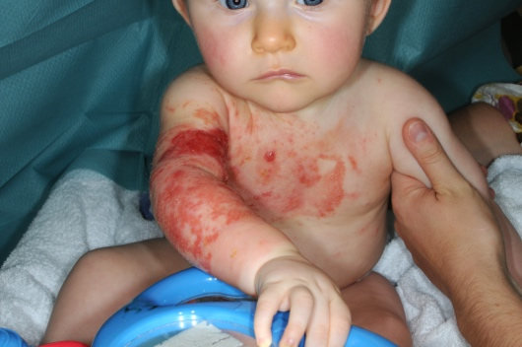

Key 1

Full-thickness burn >5% BSA
Partial-thickness burn >20% BSA
Age <5 or >50 years
Burns of face, hands, feet, genitalia, perineum, or over major joints. (03)
Inhalation injury
Circumferential burns of the chest or extremities
Chemical or electrical burns

Third professional BDS
General Surgery OSPE
Annual Examination(2019)
LMDC Lahore

Marks:3. Time Allowed: 3 min

Interactive Static Station

Topic Specification: Counseling

you are asked to counsel the patient for Tracheostomy by answering the following questions
- What is tracheostomy 01
- Will I be able to eat after this procedure? 01
- What complications can occur during the procedure 01

Key: Interactive Station:

- This procedure relieves airway obstruction or protects the airway by fashioning a direct entrance into trachea through the skin of neck (01)
- Yes, u can eat and drink (01)
- Hemorrhage, damage to Para tracheal structures, damage to trachea (01)

Third professional BDS
General Surgery OSPE
Annual Examination(2019)
LMDC Lahore

Marks:3. Time Allowed: 3 min

Interactive Static Station

Topic Specification: Counseling

How will you counsel young man who is undergoing superficial parotidectomy for pleomorphic adenoma by answering these questions

- Is there chance of malignant transformation if not treated 01
- What postoperative complications can occur 02

Key interactive Station

- Yes, it can transform in malignancy (9% in 15 years). 01
- Haematoma, infection, facial nerve injury, sialocele, numbness of ear lobe, Frey’s syndrome. 02

Third professional BDS
General Surgery OSPE
Annual Examination(2019)
LMDC Lahore

Marks:3. Time Allowed: 3 min

Interactive Static Station

Topic Specification: Counseling

A 60 years old male is planned for left hemiglossectomy and radical neck dissection for squamous cell carcinoma tongue. How will you satisfy the patient regarding following questions?
- Which structures will be removed 1.5
- What postoperative complications are expected 1.5

Key interactive station

- Submandibular gland, sternocleidomastoid muscle, accessory nerve, internal jugular vein and level 1-5 lymph nodes 1.5
- Seroma formation, infection, injury to carotid artery, injury to Vagus nerve, injury to thoracic duct 1.5

Third professional BDS
General Surgery OSPE
Annual Examination(2019)
LMDC Lahore

Marks:3. Time Allowed: 3 min

Interactive Static Station

Topic Specification: Counseling

A 20 years old female planed for excision of thyroglossal cyst. How will you answer the following questions asked by the patient?
- What will happen if I don’t get excision 1.5
- What complications can occur postoperatively 1.5

Key interactive station

- Infection, sinus or fistula formation rarely malignancy 1.5
- Recurrence, infection, seroma formation 1.5

Third professional BDS
General Surgery OSPE
Supplementary Examination(2020)
LMDC Lahore

Marks:3. Time Allowed: 3 min

Interactive Static Station

Topic Specification: Counseling

A 22 years old teacher presented with Multi nodular Goiter. She has no compressive symptoms but she is worried cosmetically
Answer the following questions regarding the counseling of patient.
1.What are treatment options 01
2.What are the complications of surgical procedure 01
3.Will she take medicine after operation and for how long 01

Key Interactive Station:

1. Subtotal or total thyroidectomy 01
2. Bleeding, hoarseness of voice, hypocalcemia, hypothyroidism 01
3. Yes. May be whole life with Follow up Thyroid function test 01

